## CERTIFIED DEVELOPER FOR KAFKA

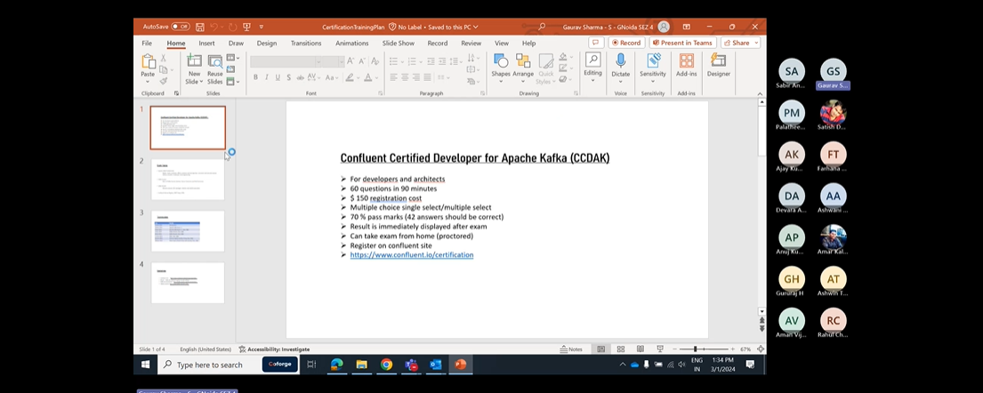

One partition can be consumed by only one consumer with in a consumer group.

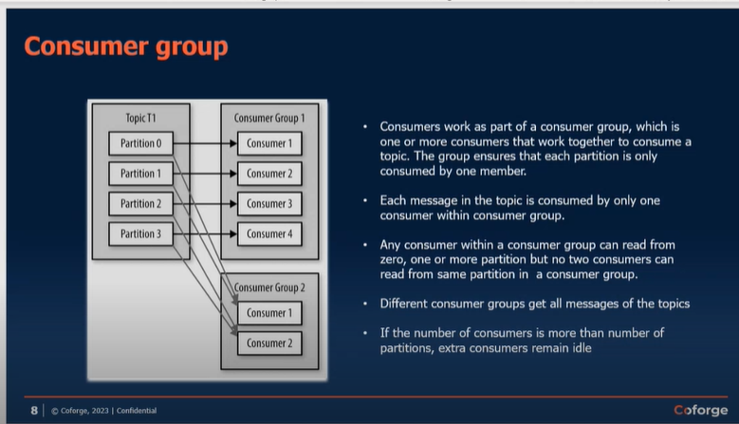

Replication factor in Kafka-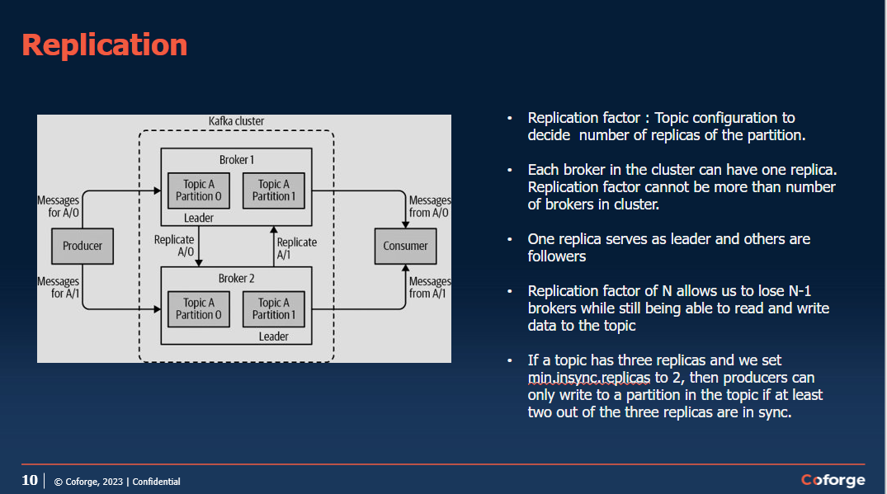

<https://richiebachala.medium.com/11-steps-for-understanding-confluent-kafka-for-data-engineers-47ab9a398bed>

go through for kafka confluent cluster details.

Zookepers are always odd numbered in Kafka Cluster .for normal organisation count is 3 and for very large organisation count can be 5.

# REST Proxy-

It is used to expose API to expose rest end point to external API’s. we cannot give access directly external applications for the kafka cluster.

Rest proxy so rest proxy is basically it will just provide the rest API OK and when the applications invoke that those rest API's they can post the messages to Kafka broker or they can just read from Kafka broker. So those kind of features that we provide rest proxy.

OK, so they don't have to connect to the Kafka broker, they can just directly put it to this API and internally this rest proxy will send it to the desired topic. OK we I will see this in details in next sessions

# Confluent KSQL-

When you want to copy some data from the topic and paste it to another topic via queries. It is done

With the help of KSQl.

Go through these things at-<https://richiebachala.medium.com/11-steps-for-understanding-confluent-kafka-for-data-engineers-47ab9a398bed>

Kafka Connect-

Kafka Streams App-

Microservice-

Confluent Control Center-

· Web based tool for managing and monitoring data pipelines and streaming applications on Apache Kafka.

· Data Stream Monitoring and Alerting using drill-down from Producer to Consumer.

· Multi-cluster monitoring and management data replication between clusters.

· Kafka Connect Configuration to add new sources to load external data systems.

· Runs on a single dedicated machine.

What is the use of Schema Registry-

Schema Registry is in the Avro format i.e. it will have data type and variable.in json we do not have any data types.

OK. Again, it depends on the producing and consuming applications which schema registry like if they want to use schema registry or not. OK suppose you serialise your message so whenever you create a record OK and you want to send it to Kafka so there are two things you need to do. One is you need to make sure that it is in proper format. OK so that consuming application can do. Second thing is you you need the Kafka has to convert it to.

A stream of bytes. OK, serialise it. OK, so you need to mention the configuration property, key serializer and value serializers. OK. There you will mention Avro and you need to give the schema registry URL. So that means it will be serialised according to your Avro schema. Whatever you have mentioned in the schema registry. OK.

Use of brokers-

* The broker receives messages from producers, assigns offsets to them, and writes the messages to storage on disk.

Controller is selected by a zookeeper.

* The controller is responsible for administrative operations, including assigning partitions to brokers and monitoring for broker failures.
* A partition is owned by a single broker in the cluster, and that broker is called the leader of the partition. Replicated partition is assigned to additional brokers, called followers of the partition

All producers must connect to the leader to publish messages, but consumers may fetch from either the leader or one of the followers.

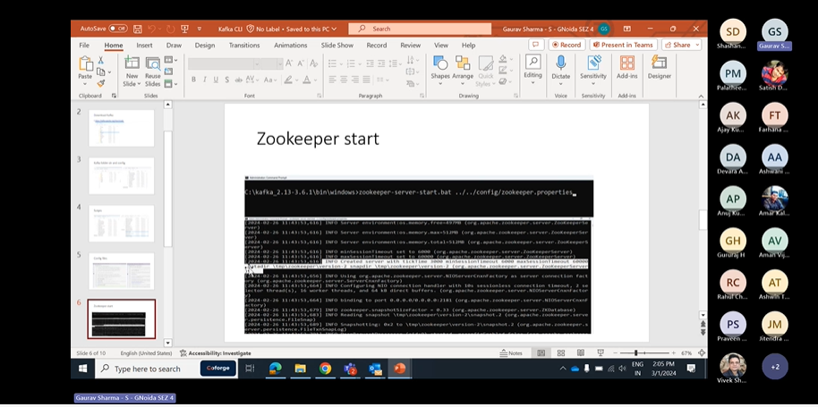

Zookeeper can be started anytime with the properties configured.

* Zookeeper cluster is called ensemble.
* Odd number of servers (typically 3 or 5)
* All servers need to have common configuration file
* Quorum : majority of the servers should be running to form a quorum Q=2N+1
* Configurations:
  + tickTime:2000
  + dataDir:/var/lib/zookeeper
  + clientPort:2181
  + Server1 : hostname: peerPort: leaderPort
  + Server2
  + Server3
  + initTime : the amount of time to allow followers to connect
  + syncLimit : value limits how long out-of-sync followers can be with the leader.

# Cluster membership

* Each broker has a numeric broker id , mentioned in the config file.
* Broker registers itself with the zookeeper using this id creating ephemeral node
* Each broker in a cluster has unique id
* The first broker to register itself with the zookeeper becomes controller.
* If controller goes down, other brokers attempt to become controller
* Controller helps in selecting leader partitions.
* Zookeeper selects controller and stores metadata (brokers, topics, partition, replicas)

# Partition allocation

* Assume 4 brokers, new topic with 4 partitions and a replication factor of 3

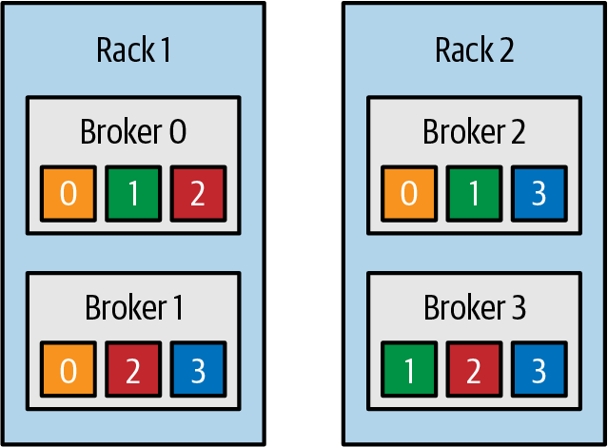

Topic is divided into partitions, partition is divided into segments for the purpose of writing data to the disk. Segment file can be retained for time duration or based size limit.

Active segment is not deleted.

If fewer messages are expected, retention should be maintained on time basis

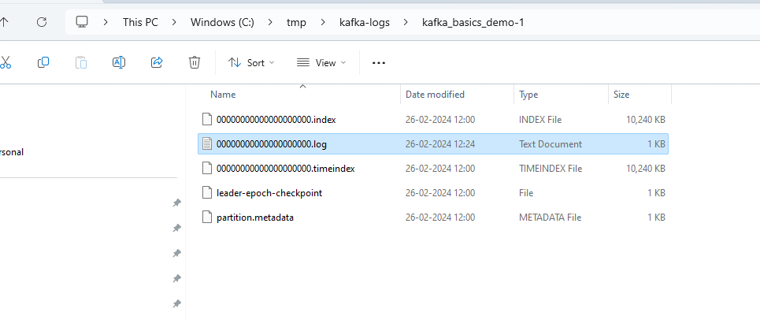

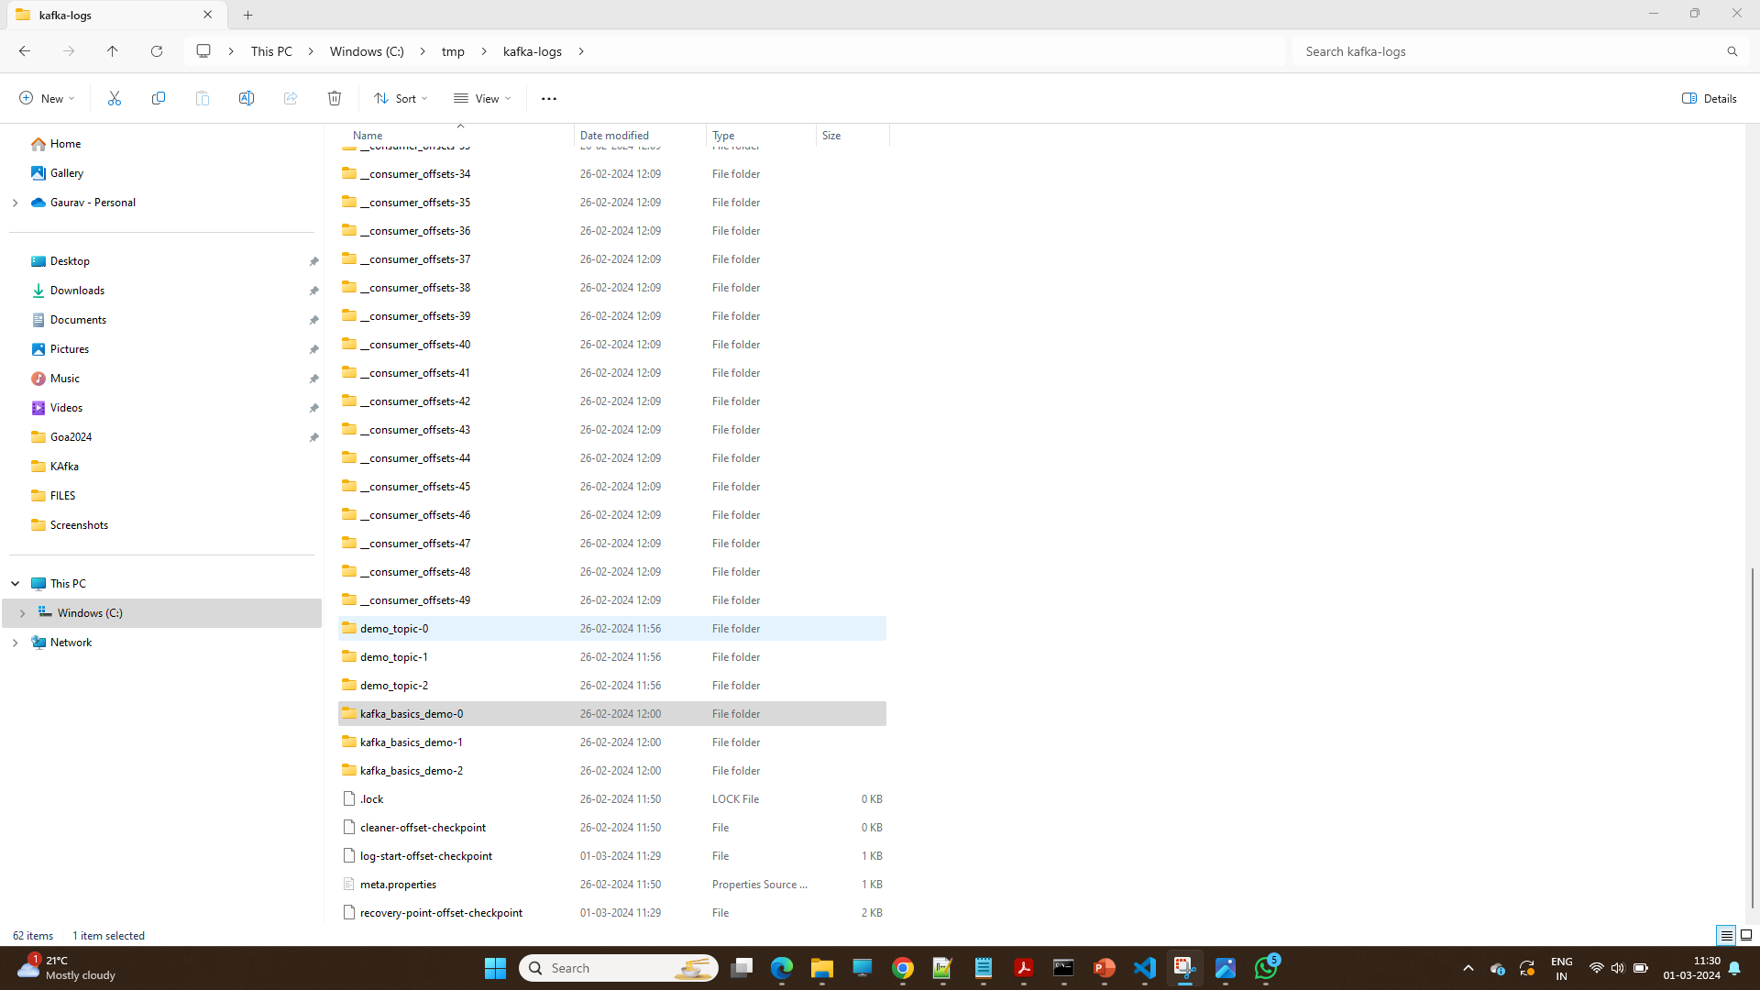

In kafka Topic is divided into partitions, partition is divided into segments for the purpose of writing data to the disk. Data is stored in the form of segments once the segment is complete to specific space.it will create another segments to store the data.

If producer is slow ,we can configure it will create another topic after specific time interval.

# KAFKA Producer-

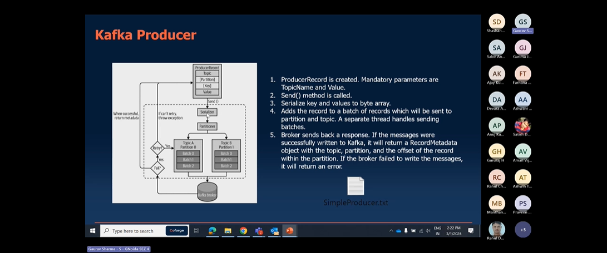

Retry Mechanisms-

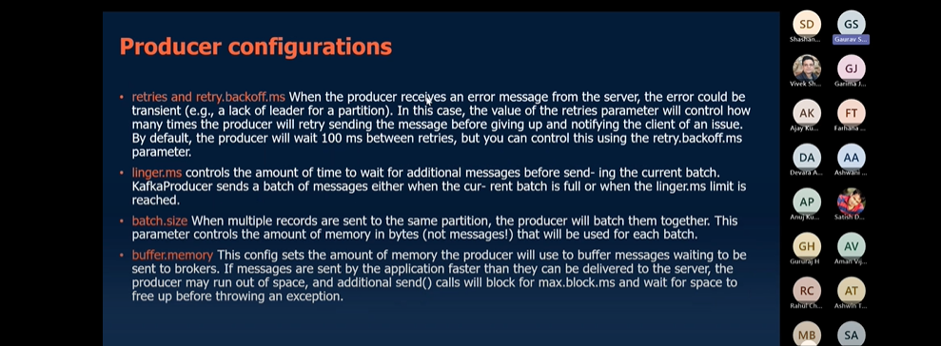

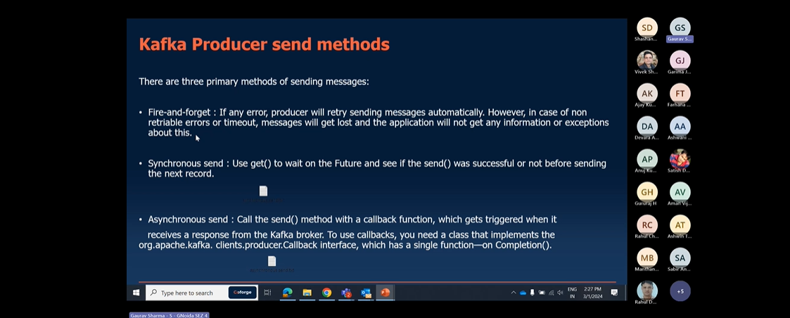

Fire-forget🡪send msg and forget ,if data lost it is not observed by our app.

Synchronous send🡪single thread mechanism it will wait until the acknowlwdgement received from kafka.

Asynchronous send🡪multithreaded mechanism , one thread will pass by and another thread will wait for Acknowledgement.

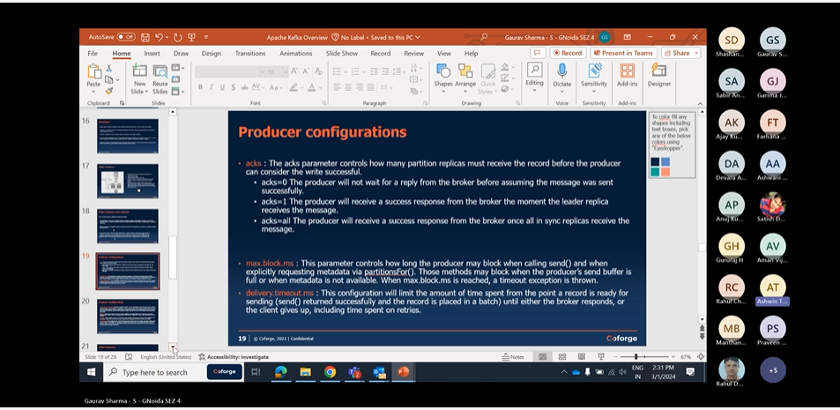

“Not Enough Replica”-

Like as if we want replica to backup. and we have Replication factor:4 and minimum insync replicas :3 and we have two of our broker down ,so it will not be possible for us to get acknowledgement giving “ “Not Enough Replica” error.

reduce value:”insync replicas “ .it will work

# Producer Configurations

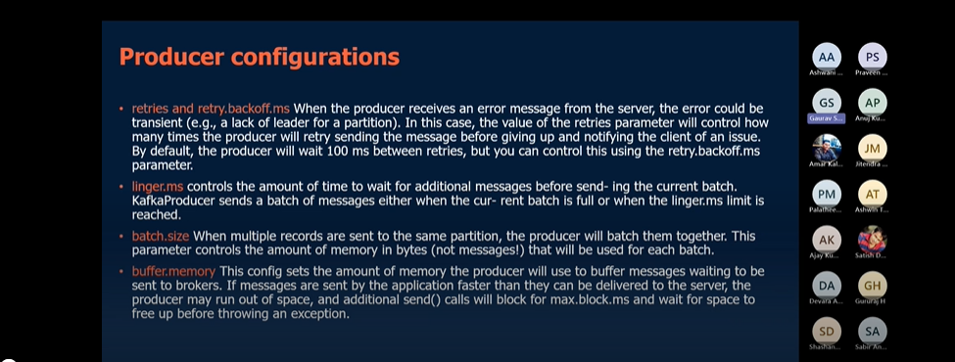

Retry.backoff.ms🡪time between each retry.

**Linger.ms**🡪sometimes the producer is too slow and the producer will wait for this much time only before pushing messages to kafka.if this much time is passed it will push the messages.

**Batch size**🡪if your producer is fast than you can increase the batch size and you can push messages at faster rate.

Kafka Consumer:-follow multiple configurations , without which it will not start the kafka Consumer.

BootstrapServers

Key.deserializer

Value.deserializer

Kafka Consumer have following properties-:

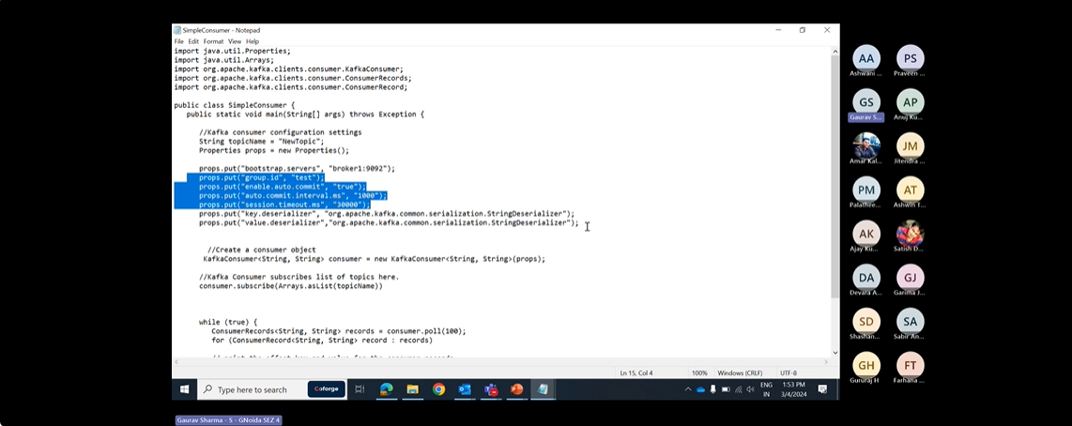

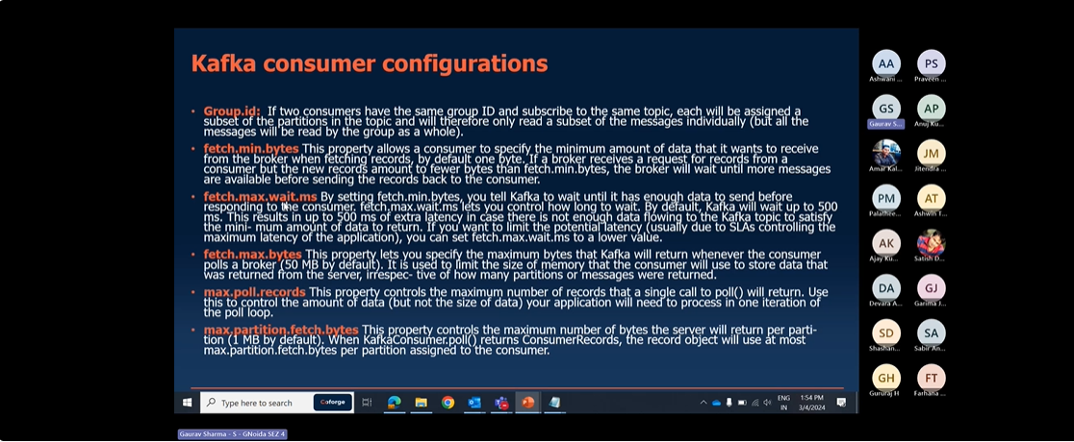

Fetch.min.bytes:-by default it is 1 byte.if a broker gets request,but a new records amount less than fetch.min.bytes .broker will wait for for more Records before sending.

Fetch.max.wait.ms-since the broker waits for records to come because of fetch.min.bytes it increase the lag.by default wait time is 500 ms .we can reduce it as per our wish.

Fetch.max.bytes-it specifies the maximum bytes that kafka will return whenever consumer polls a broker.it is used to limit the size of a memory that consumer will use to store the data that was returned from server.

Max.partition.fetch.bytes-it specifies the maximum number of bytes server return per partition.

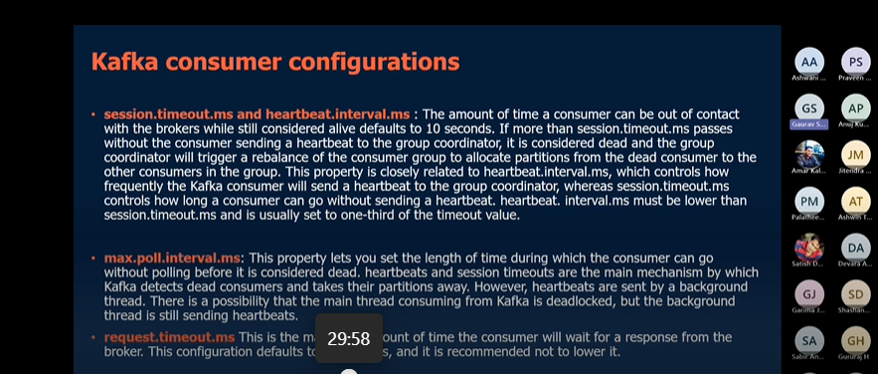

Session.timeout.ms -The amount of time a consumer can be out of contact with brokers while still alive defaults to 10 seconds. if more than session.timeout.ms passes without the consumer sending a heartbeat to group coordinator,it is considerd dead and the group group coordinator will trigger a rebalance of a consumer group to allocate partitions from dead consumer to other consumers.

heartbeat.interval.ms -it controls how frequently kafka consumer will send heartbeat to group coordinator.

Generally Session.timeout.ms and heartbeat.interval.ms are closely related to each other. Session.timeout.ms basically defines the time in which consumer can go without heartbeat.it is generally Session.timeout.ms set to 3 times heartbeat.interval.ms

Max.poll.interval.ms-

Lets you set the length of time during which consumer can go without polling before it is considerd dead. Heartbeat and Session timeout are the main mechanisms by which kafka detects the dead consumer and takes their partition away.and there can be scenarios in which main thread is deadlocked and background thread is sending heartbeats.

Request.timeout.ms:-maximum amount of time consumer will wait for response from broker. The

Configuration defaults to 30 s.it is recommended to lower it.

Auto.offset.reset-it controls the behavior of consumer when it starts reading a partition which doesnot have commited offset or if the offset it has commited is invalid.

Earliest:means it starts reading from earliest offset

Latest: means it starts reading from the latest offset or new available offset

None: if we set it to none .it will automatically give an exception and consumer will be stopped automatically.

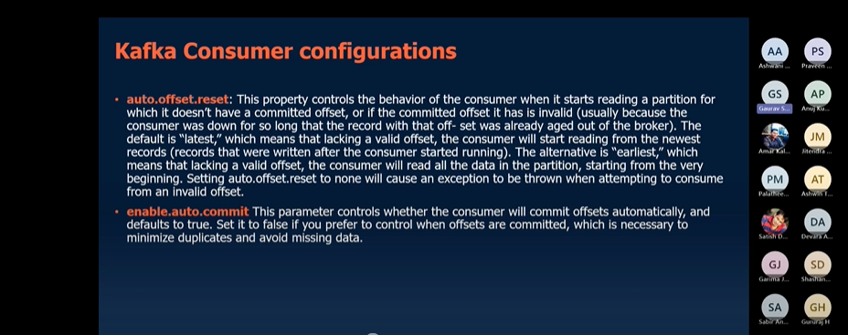

Enable.auto.commit: -either you will commit automatically or you will commit manually within code.

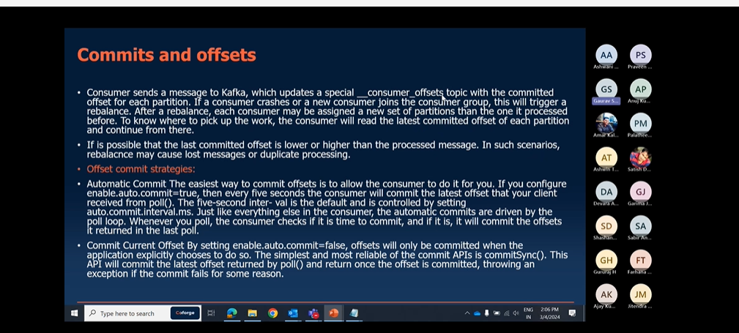

CommitSync-means you are Synchronously commiting the offset.In this we have risk of losing the records i.e commiting the records before processing.

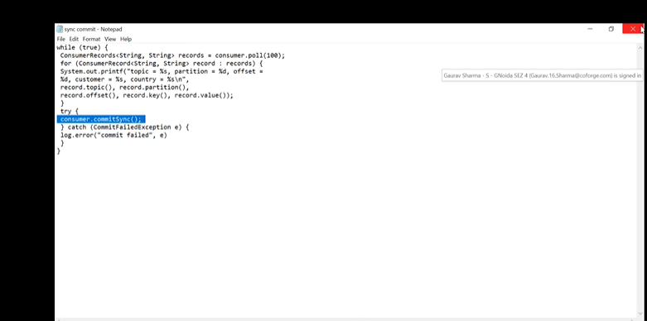

Asynchronous Commit-: **one drawback of manual commit is that application is blocked until the broker responds to commit request**.This will limit throughput of the application.Throughput can be improved by commiting less frequently.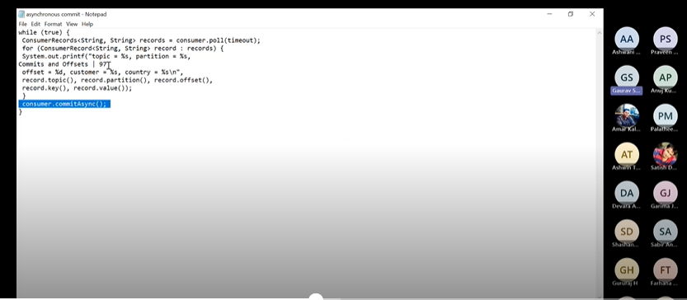

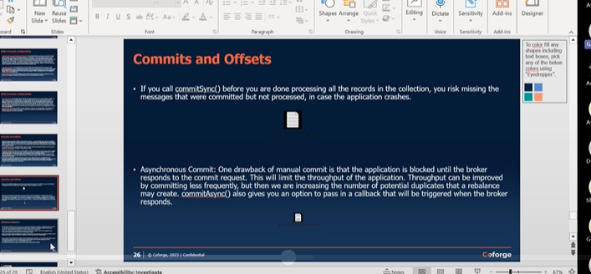

Rebalance:-

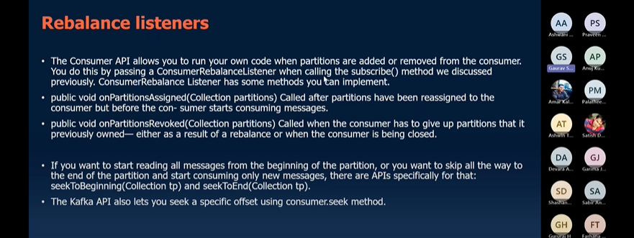

# KAFKA CONNECT-

It is Another way to push data to kafka and push data from kafka to external sources.Kafka connect provide connect Api which provide easy to use configuration in kafka. There are multiple libraries that multiple developers have written.which are very easy to use.

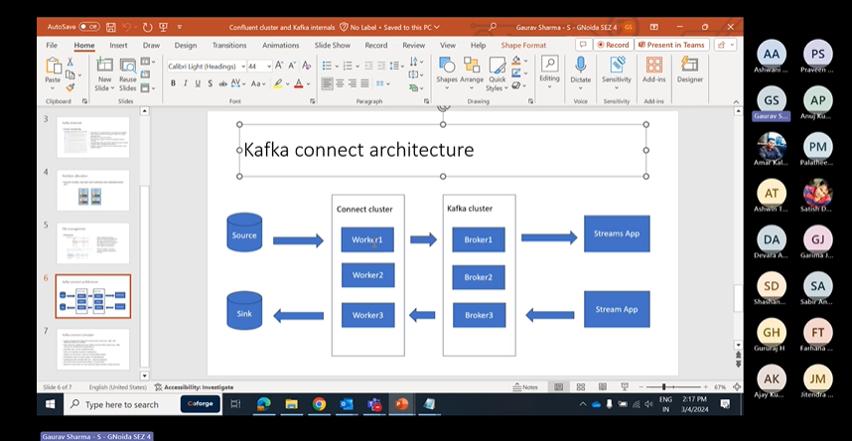

OK, So what happens is there are many libraries which many developers have written K both open source as well as confident libraries which are like very easy to use.

And this connect API right there is an API provided by Kafka which is called **Connect API**.

This provides an easy to use configurations like.

We can just configure to use one of those libraries, OK and it will start.

It will start the JVM and it will start getting messages in two Kafka from external sources or from Kafka to external data syncs.

OK, so there are two kinds of connectors.

We can create one is source connector which will receive data from outside to Kafka and sync connectors which will just push messages from Kafka to outside.

Data syncs.

OK.

So two kind of connectors we have.

OK, this is how the connect architecture looks like.

So we have the Kafka cluster, we have the brokers here and for connect connect cluster for a connectors we can have another cluster like we can have many other servers which are which where we can run this connect and we these will have the same group ID's OK like for Kafka cluster we were using a broker idea Broker 0 Broker 1 broker 2 like that here also we have a similar kind of configuration.

We can have multiple servers where we can run this, connect multiple nodes and these will work together to distribute the load and create the task for source and sink connectors.

OK, so these are called workers.

OK, Kafka connect cluster is there and I'll just show you how to start it

Working of kafka connector-

Config-

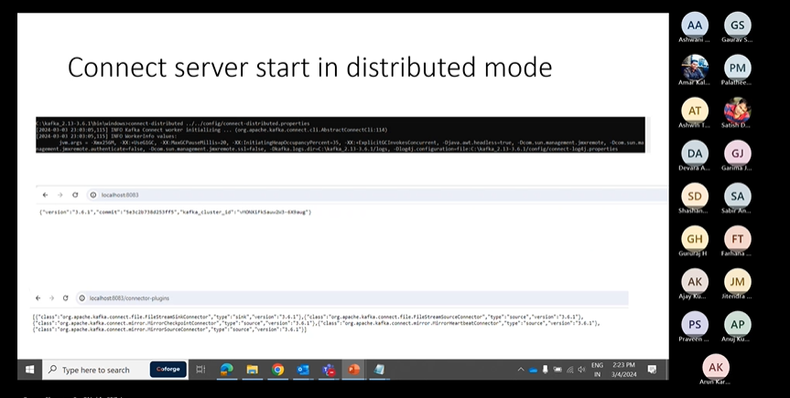

OK, I just created one file topic, the topic where I want to put the content, OK and then I've given the you are like this one.

OK, this is the API I'm calling local city.

It is collectors.

OK, then it creates the connector.

OK, this is the file I've shown input file where it has a I just written 3 lines here OK and once the connector is created it will start pushing the content to this topic.

OK, I'll started a console consumer here and you can see it comes in the JSON format.

It's coming like this.

Payload uh is your first message.

Secondly, from the file it it just yeah, uh pulls it to Kafka.

OK.

And if I go to this API connect us, I can see there is one connector here now.

OK, so Kafka input.

This is the one which I just created here.

So is demographically OK, and if I want to see the configuration I can just go to this connector.

I just check the URL connector slash so semeka input and I will see the details like what is this connector, the connector classes here file is here.

Name, topic.

Everything is here, OK?

And to check the status I can just put the status here.

OK, status done.

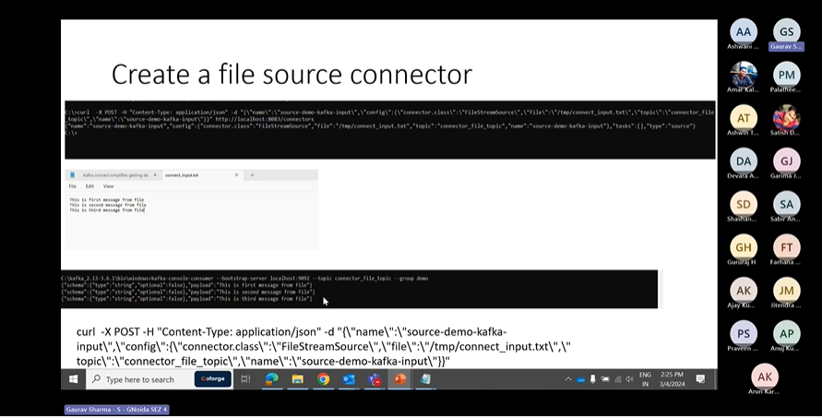

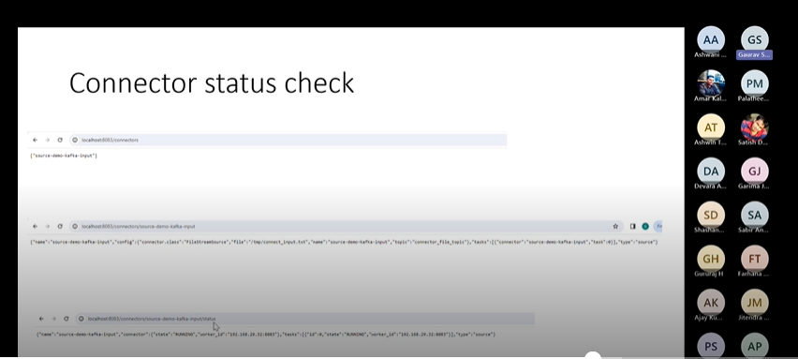

Delete Connectors-

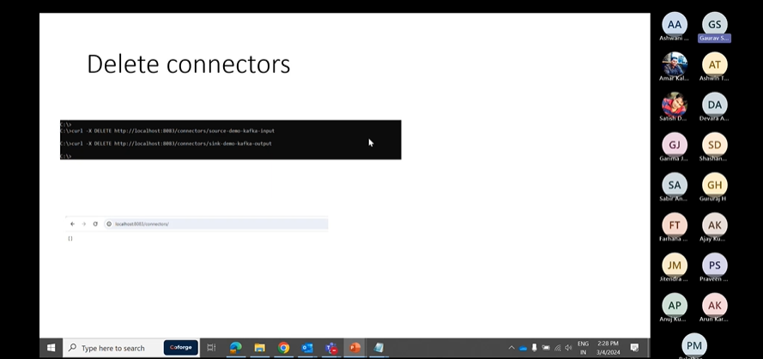

QUIZ

Q1)

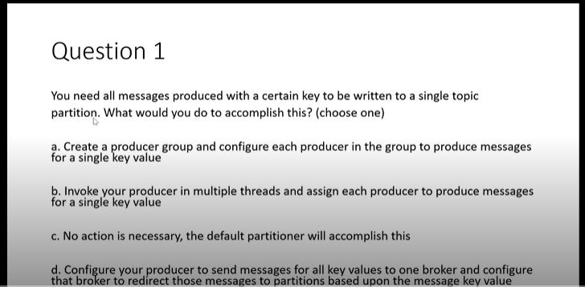

c.)because kafka stores the data in the form of hashing. It will store the data specific to partition automatically.

Q2)

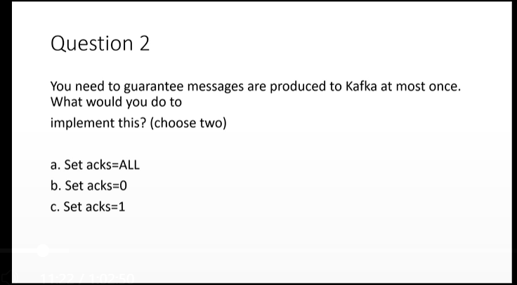

b),c) since acks=0 we would not get any responses from Replica.it is like fire and forget.

Acks=1 we would get Responses from replica at least once.

Acks=ALL mean we would be waiting for responses from multiple replicas.

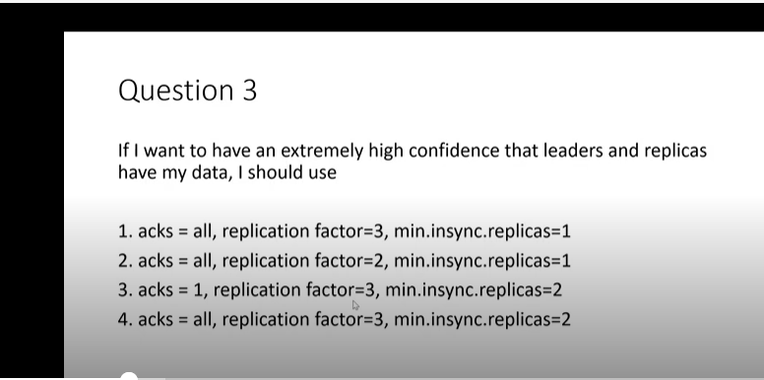

4)most reliable

Q4)

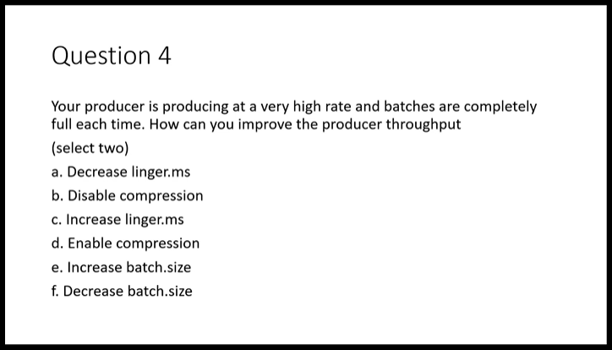

a),e)linger.ms it is the max time producer wait before pushing batch to kafka.

batch.size-it is size of batch to be pushed to kafka.

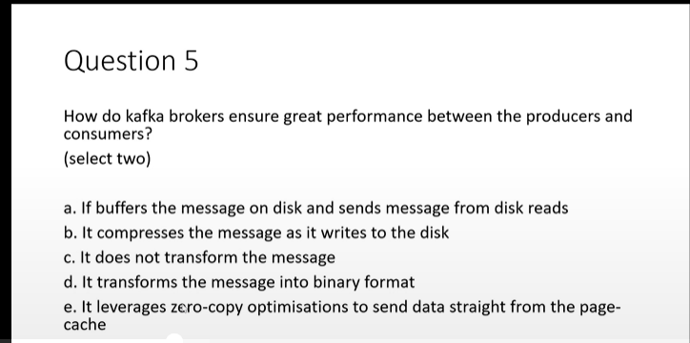

Q5)c),e) kafka does not transform the messages producers and consumers automatically serialize and deserialize the messages.

e)as if we can send messages directly to consumers.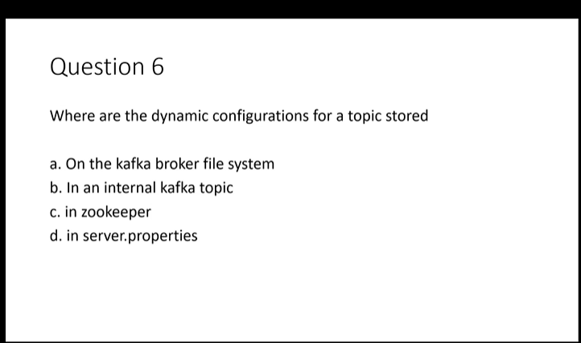

b) configurations are stored in internal kafka topic.zookeper just manages leader and metadata other stuff.

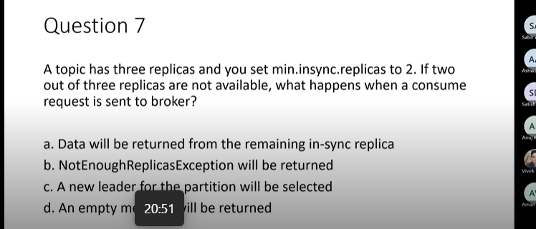

b)

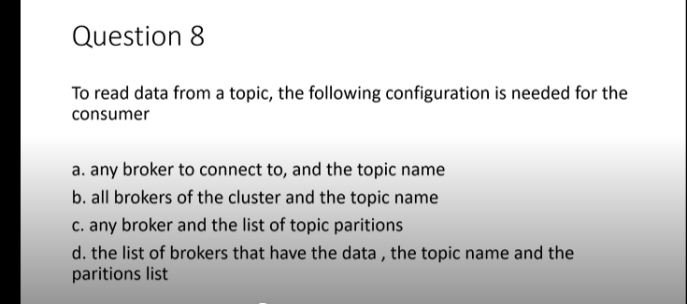

a)only one broker is enough to connect to a particular topic.we give list of broker if a particular broker is not available so it can check other brokers.

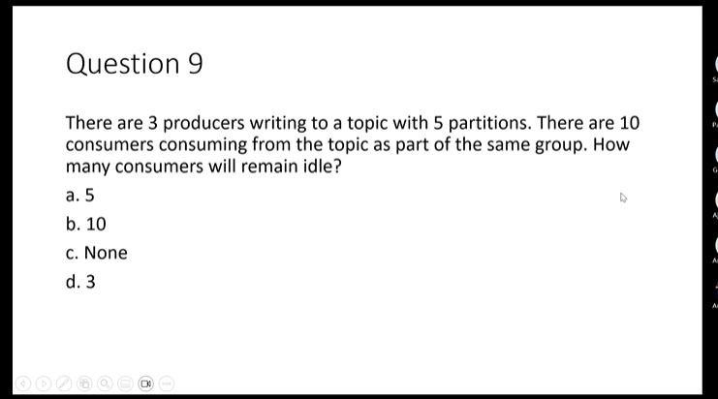

a)since only one consumer will consume at max from a particular partition. Remaining consumers will remain idle in such scenarios.

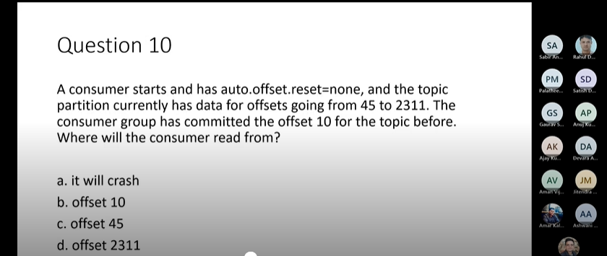

a)it will crash ,as will search next offset i.e 11 which it will not find.

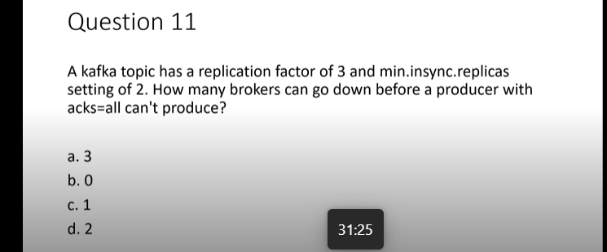

c) 3 brokers 2 must be in sync one can go down.

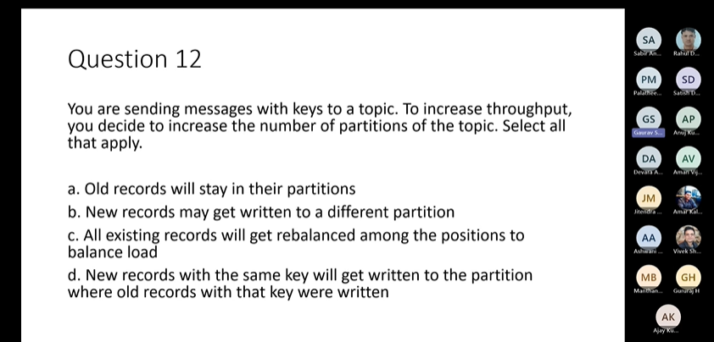2

a),b)

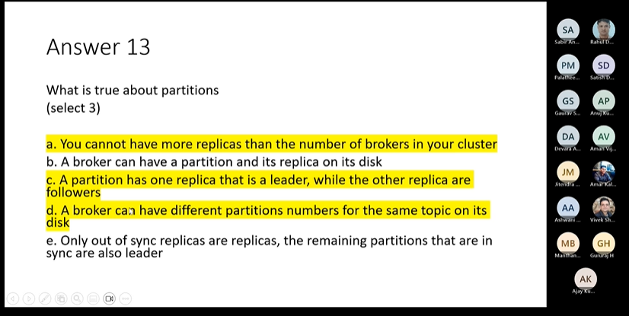

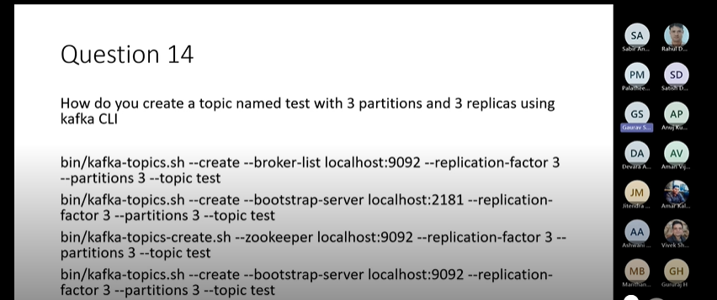

4)

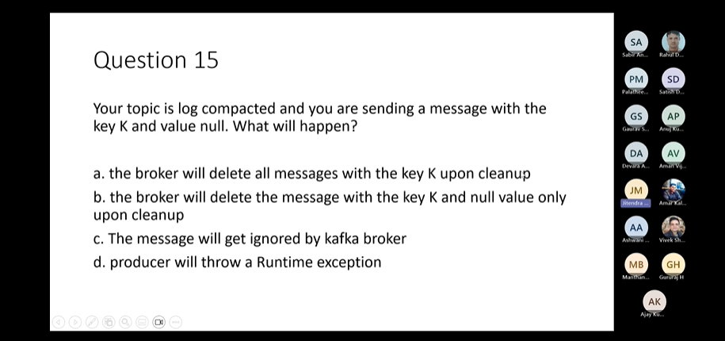

a

KAFKA STREAM CONCEPTS-

Kafka Schema Registry:-

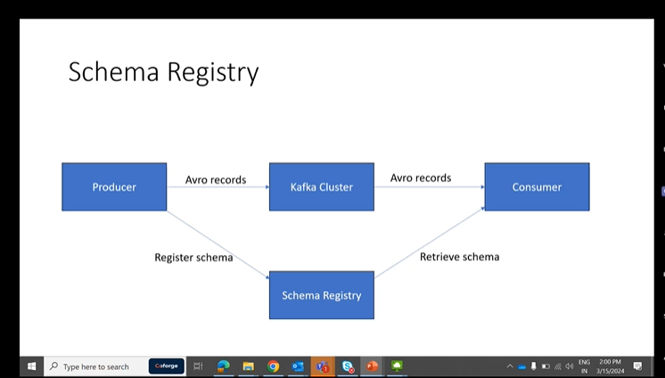

When Producer want to send message through kafka so message must be as per schema. Producer is producing the records and Consumer is consuming the records if producer will send the record along with schema, the record will be very heavy.

So what it what it does is it can register the schema and schema registry OK and when it registers it will get an ID OK scheme ID.

Can send that ID in all the messages, OK consumer when it gets the messages that will use that ID to retrieve the schema and it will deserialize and read that message. OK, so this is the idea about schema registry.

Yeah, simple idea. Could be subclass the record, serialises the record using every serializer, adds a schema ID consumer will use that every deserializer and schema schema ID to deserialize the record.

OK, so these are the services schema history is providing. It allows the producer and consumers to communicate what are well defined data contract in the form of schema. Then it is facilitating the communication by storing the schema. OK, it controls schema evaluation with clear and explicit compatibility rules. So what does it mean? It means that suppose today we have a schema, we have 10 fields OK and producer and consumer set up using that schema for communication.

Tomorrow there is a business requirement to add one more field. OK, so that will be stored as next version of the schema. OK Version 2 and we have certain set of rules like it should be backward compatible or forward compatible. We'll discuss those in details. So according to that the schema registry will accept the new schema or it will reject it. OK, if it doesn't fit with the rules it will reject it. So why? Why that happened? Because the production should not break the communication should not break.

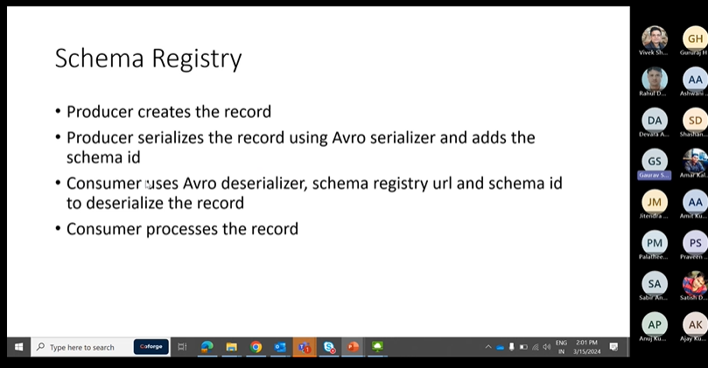

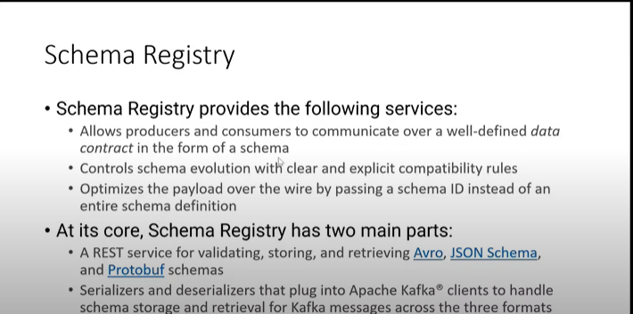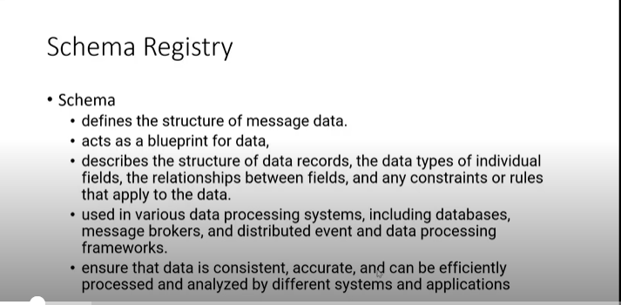

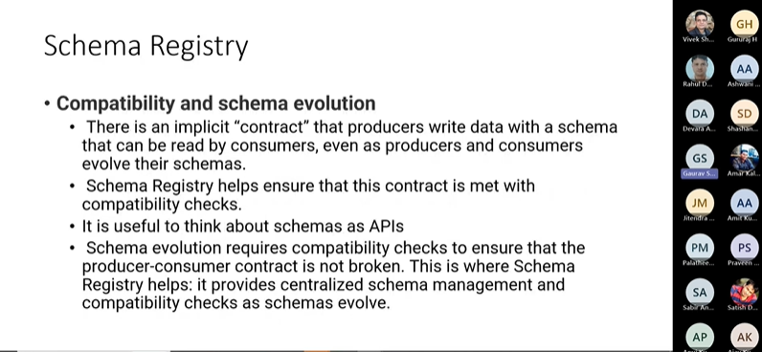

**Data Serialization** means process of converting data structures or objects into format that can be transmitted across a network.

Confluent Schema Registry supports AVRO,Json Schema Serializers and Deserializers(serdes).

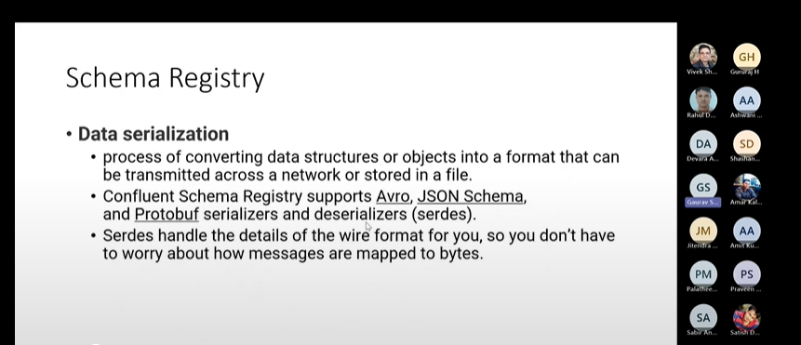

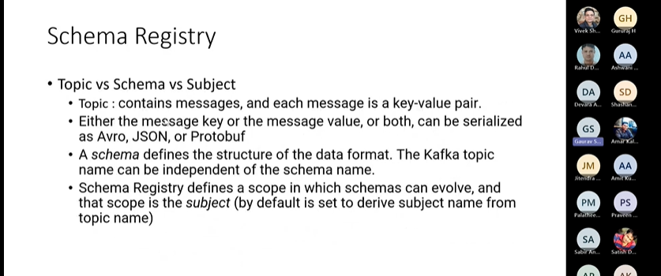

If we want to put a change in schema ,the version of a schema must be upgraded.

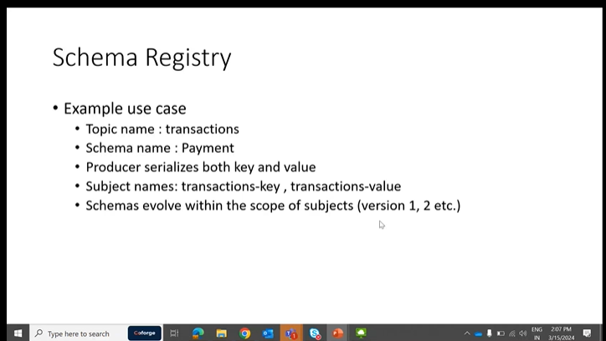

How to get latest Schema and values.

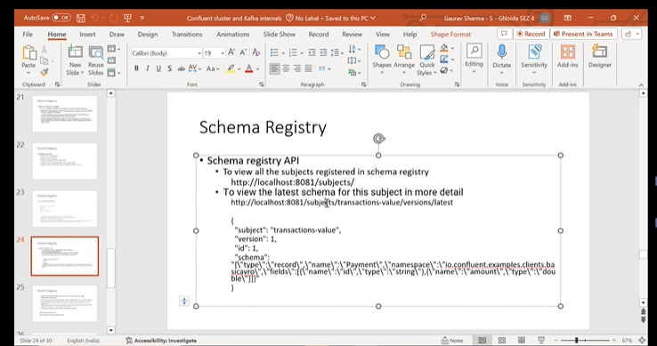

Schema Registry:-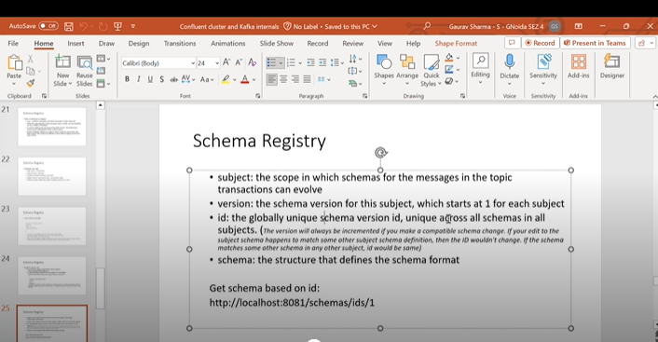

In schema registry the Schema ID’s are generated. if there is any change in Schema, a new version of the Schema will be generated automatically. If any other subject is using a particular schema then it will generate same id of that schema in a subject.

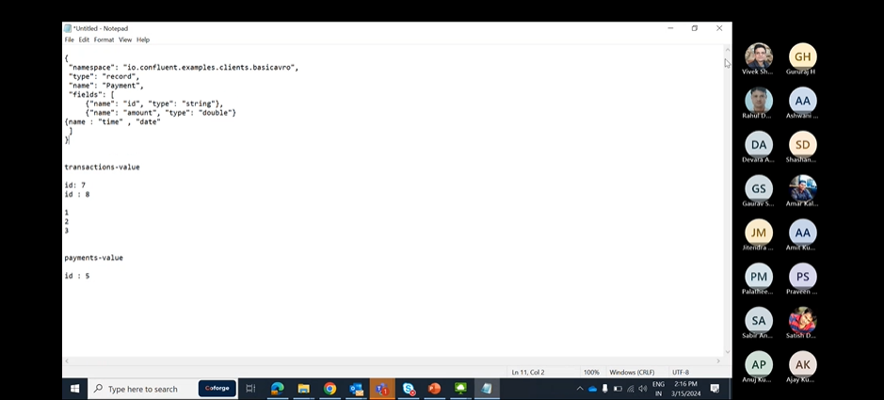

We generally get the schemas using subject and Schema and we can get the schemas using Id’s as well.

:8081/schemas/ids/64

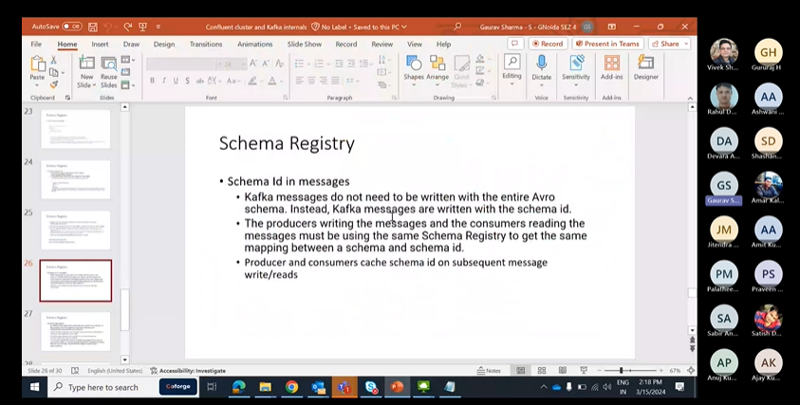

Schema Registeration:-

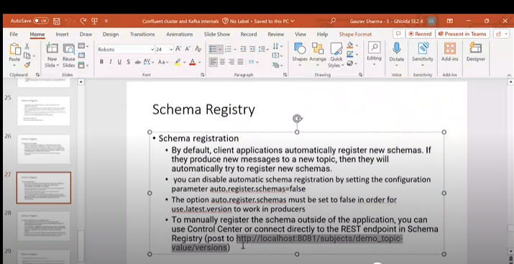

Schema Registry Compatibilty

BackwarD: Consumers using V3 can read the data written by producers using V2 Schema.

Backward\_Transitive:-Consumers using V3 can read data written by producers using Previously Registerd Schemas(V1,V2).

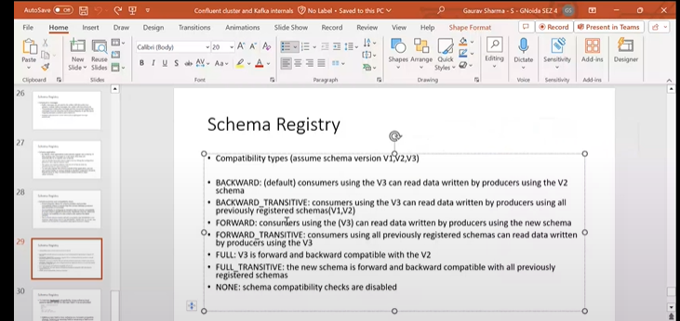

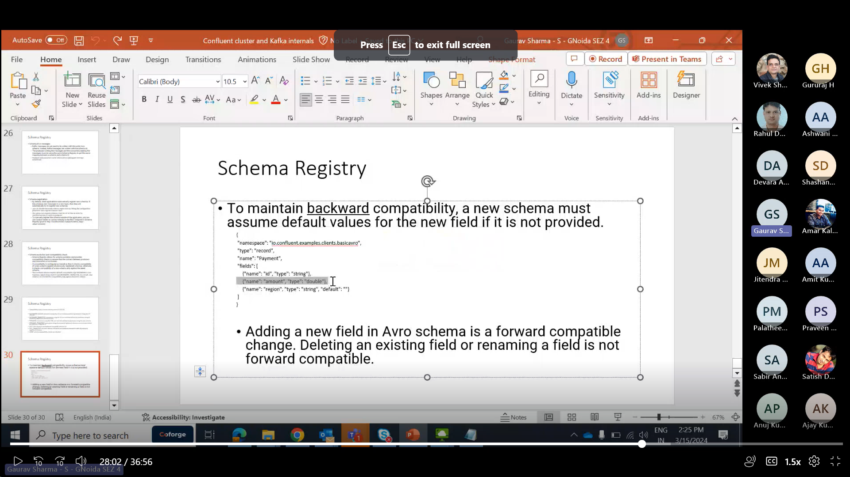

In the example above it is backward compatible as producer is using old schema and do not sends the new region field as per new schema, so it will not cause issue as region is set to default.it will ignore.

If you change anything with the Schema i.e amount ,it will not pick up and probably give serialization errors.

You can go through this page for better understanding:- https://docs.confluent.io/platform/current/schema-registry/index.html

KSQLDB-https://docs.ksqldb.io/en/latest/developer-guide/ksqldb-reference/

Q)ONE of the four core ApI’s of Kafka-

Admin API

Q)For Kafka,what is proper value of heap size?

6GB

Q)false statement for Zookeper znodes?

zNodes can be renamed through CLI. sc

Q)Which consumer becomes the group leader of a consumer application?

First consumer to join the group.

Q)Replication factor=3,min.insync.replicas=2,acks=all which exception is thrown?

Exception:NOT\_ENOUGH\_Repicas

Q)which Network Protocol is used by Kafka to achieve high performance?

TCP

Q)Fetch rate is high and each fetch is small.How to maintain throughput?

Increase fetch.min.bytes.

Q)After a forward schema evolution,which order of upgrading producer and consumer clients should you prefer?

Upgrade producer first.

| **Compatibility Type** | **Changes allowed** | **Check against which schemas** | **Upgrade first** |
| --- | --- | --- | --- |
| BACKWARD | * Delete fields * Add optional fields | Last version | Consumers |
| BACKWARD\_TRANSITIVE | * Delete fields * Add optional fields | All previous versions | Consumers |
| FORWARD | * Add fields * Delete optional fields | Last version | Producers |
| FORWARD\_TRANSITIVE | * Add fields * Delete optional fields | All previous versions | Producers |
| FULL | * Add optional fields * Delete optional fields | Last version | Any order |
| FULL\_TRANSITIVE | * Add optional fields * Delete optional fields | All previous versions | Any order |
| NONE | * All changes are accepted | Compatibility checking disabled | Depends |

**In forward schema validation the fields are added,even if we add upgrade consumer first we will not get the data as producer is unable to produce with added field,so better upgrade producer first only**.

**In Backward schema validation few fields are deleted so to avoid any invalid data now in consumer with additional fields consumer first.**

FORWARD compatibility means that data produced with a new schema can be read by consumers using the last schema, even though they may not be able to use the full capabilities of the new schema.

BACKWARD compatibility means that consumers using the new schema can read data produced with the last schema. For example, if there are three schemas for a subject that change in order X-2, X-1, and X then BACKWARD compatibility ensures that consumers using the new schema X can process data written by producers using schema X or X-1, but not necessarily X-2

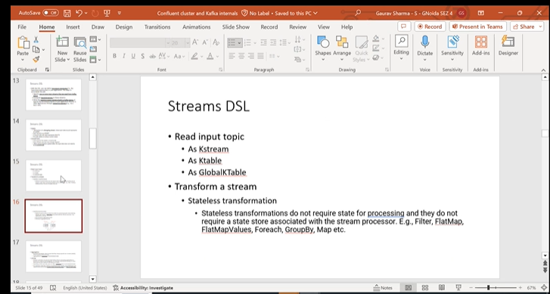Stateless transformations do not require state for processing and they do not require a state store associated with the stream processor. Kafka 0.11.0 and later allows you to materialize the result from a stateless KTable transformation. This allows the result to be queried through [interactive queries](https://kafka.apache.org/20/documentation/streams/developer-guide/interactive-queries.html#streams-developer-guide-interactive-queries).

Stateful Transformations:-

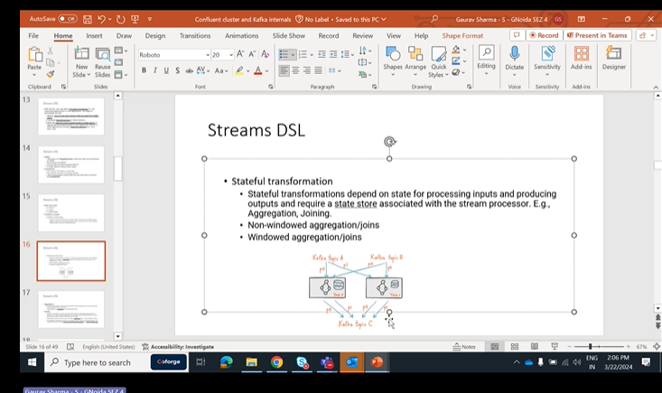

### [Stateful transformations](https://kafka.apache.org/20/documentation/streams/developer-guide/dsl-api.html#id11)

Stateful transformations depend on state for processing inputs and producing outputs and require a [state store](https://kafka.apache.org/20/documentation/streams/architecture.html#streams_architecture_state) associated with the stream processor. For example, in aggregating operations, a windowing state store is used to collect the latest aggregation results per window. In join operations, a windowing state store is used to collect all of the records received so far within the defined window boundary.

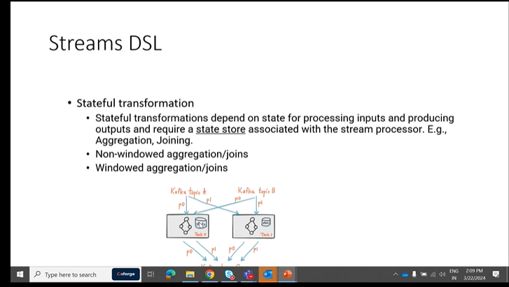

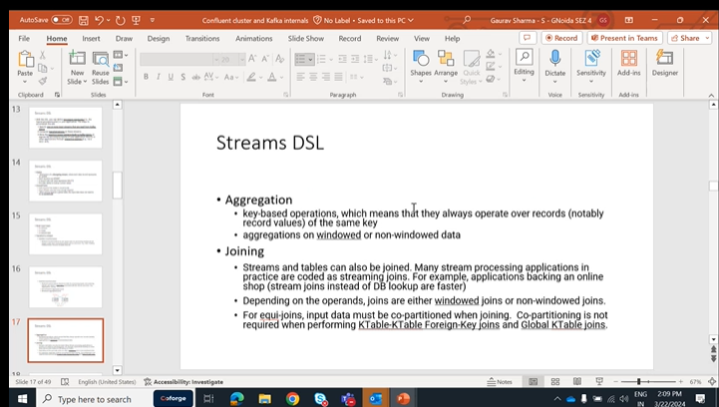

 That is, scenarios where you need to perform table lookups at very large scale and with a low processing latency. Here, a popular pattern is to make the information in the databases available in Kafka through so-called change data capture.

| **Join operands** | **Type** | **(INNER) JOIN** | **LEFT JOIN** | **OUTER JOIN** |
| --- | --- | --- | --- | --- |
| KStream-to-KStream | Windowed | Supported | Supported | Supported |
| KTable-to-KTable | Non-windowed | Supported | Supported | Supported |
| KStream-to-KTable | Non-windowed | Supported | Supported | Not Supported |
| KStream-to-GlobalKTable | Non-windowed | Supported | Supported | Not Supported |
| KTable-to-GlobalKTable | N/A | Not Supported | Not Supported | Not Supported |

KStreams is an important topic,need to go through it.

[https://kafka.apache.org/20/documentation/streams/developer-guide/dsl-api.html#streams-developer-guide-dsl-joins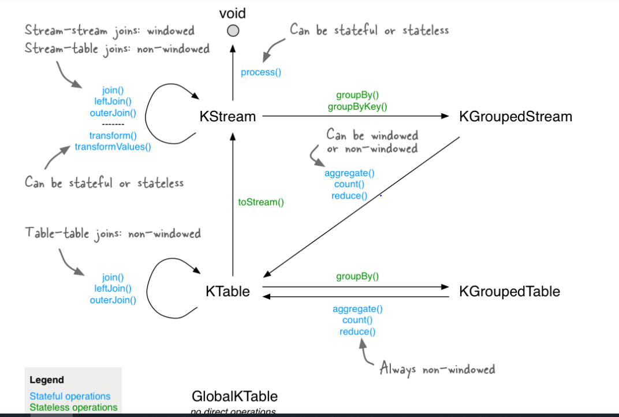](https://kafka.apache.org/20/documentation/streams/developer-guide/dsl-api.html#streams-developer-guide-dsl-joins)

Straightness operations K stream to K Stream joins are stateful operations. Case stream to K Stream joins straight full operations because K streams are continuous unbounded data set. So we need to define some kind of window to to a join. OK, so this is windowed join and stateful join OK.

And then we have a.

K Table Table Table joins this. Those are known nonindowed joins. OK, so those are also stateful operation but they are not windowed. So that means we don't because K table is static like it's just maintaining the latest value of the keys. OK so we don't have to. It is nonwindow like we can do the join at a time. We can do it over complete K table. We don't have to define the windows OK.

Then we have a we can convert K table to K string which is a stateless operation to string. So these kind of things are given. You can just read it and go through the documentation. We understand it.

So this is the important thing Windows. What kind of windows are available to us? OK, to do the operations and this go back to this one.

The windowing part.

Yeah. So we're doing, let's control how to group records that are the same key for stateful operations such as aggregations or joins into Windows. OK for record key, let's say.

Do you want to do a count over last five minutes? OK, with the hopping window, that means every one minute the window will change. So here if you see green coloured, let's say green coloured is key one, OK and you are just doing the aggregation 0 to 5, zero to 5 minutes. OK so as soon as one minute passes.

Your window becomes 126 OK.

SMS second passes your operation. Your window becomes 227. OK, so this is hopping like one. One minute hop is there OK and five minutes is the window time. OK, so this way you're doing the aggregation so in colour is key. Once blue coloured is another key. OK, so you can see how it is changing.

It's this is hopping window.

Then you have tumbling window tumbling Windows Zero to five. You have some kind of you have the window zero to five minutes and after 5 minutes have passed another window starts 5 to 10 minutes. OK. So for 5 minutes the state remains the same. The Count will remain the same for 1st 5 minutes or whatever window duration you are given and as soon as that duration is passed again another state will start like another aggregation will start OK 5 to 10 minutes.

OK, this aggregation will happen after the duration pass. Another aggregation will happen. So this way it will happen OK states to like will be there for 5 minutes. After that again another one will start, another window will start.

This is doubling window.

slinding window it's it's same as the hopping window, but the window the the hop like there one minute hop right? But here it is very small like 5 milliseconds so it it almost slides like it's just.

Sliding over within 55 milliseconds, the window is changing OK and also there is one more concept here. It will work on difference between record time stamp so it will just calculate the difference between 2 records and if it is less than five. If it is more than five milliseconds do you just add it in the in this one?

It in the the aggregation or whatever population here does.

Sliding window and hopping window are almost the same actually, except that here the the gap duration is very small so it looks like a continuous slide.And we have session Windows session windows means the session is created OK and if let's say we are getting the keys here P1 is received at first minute, first, zeroth, minute.

And then we have another.

Kiat 60 minutes and we say session window 5 minutes gap. So if for the first five for the five minutes after receiving this we are not getting anything. So that means it's an, it's a gap of inactivity. So there is no event with that same key is received. That means we'll start a new aggregation. After that we'll not, we'll just discard it. OK. If there is a gap of five minutes. So this is what happens when the customer calls in, right?

There's a gap of inactivity. It's not doing anything a session time so. So similarly, there is a time out, five minutes. OK. And what's that? 5 minutes is passed between this timeout and start a new session. After that, whenever the new event is received and that session will start from this one OK. And if there is a inactivity of five minutes, it will just again timeout. But let's say if we are getting more events here before the five minutes have expired so session will continue.

Gaurav Sharma - S - GNoida SEZ 4 27 minutes 28 seconds

OK, session will continue. OK. I need to just keep on adding or aggregating the events, OK.

Gaurav Sharma - S - GNoida SEZ 4 27 minutes 37 seconds

That that is session windows.

Gaurav Sharma - S - GNoida SEZ 4 27 minutes 40 seconds

So these these are three four kind of windows. You need to remember because they will ask it in the exam for sure.

Gaurav Sharma - S - GNoida SEZ 4 27 minutes 49 seconds

Mostly what is the difference between hopping window and tumbling window? Those kind of things they must.

Gaurav Sharma - S - GNoida SEZ 4 27 minutes 56 seconds

And go through the documentation.

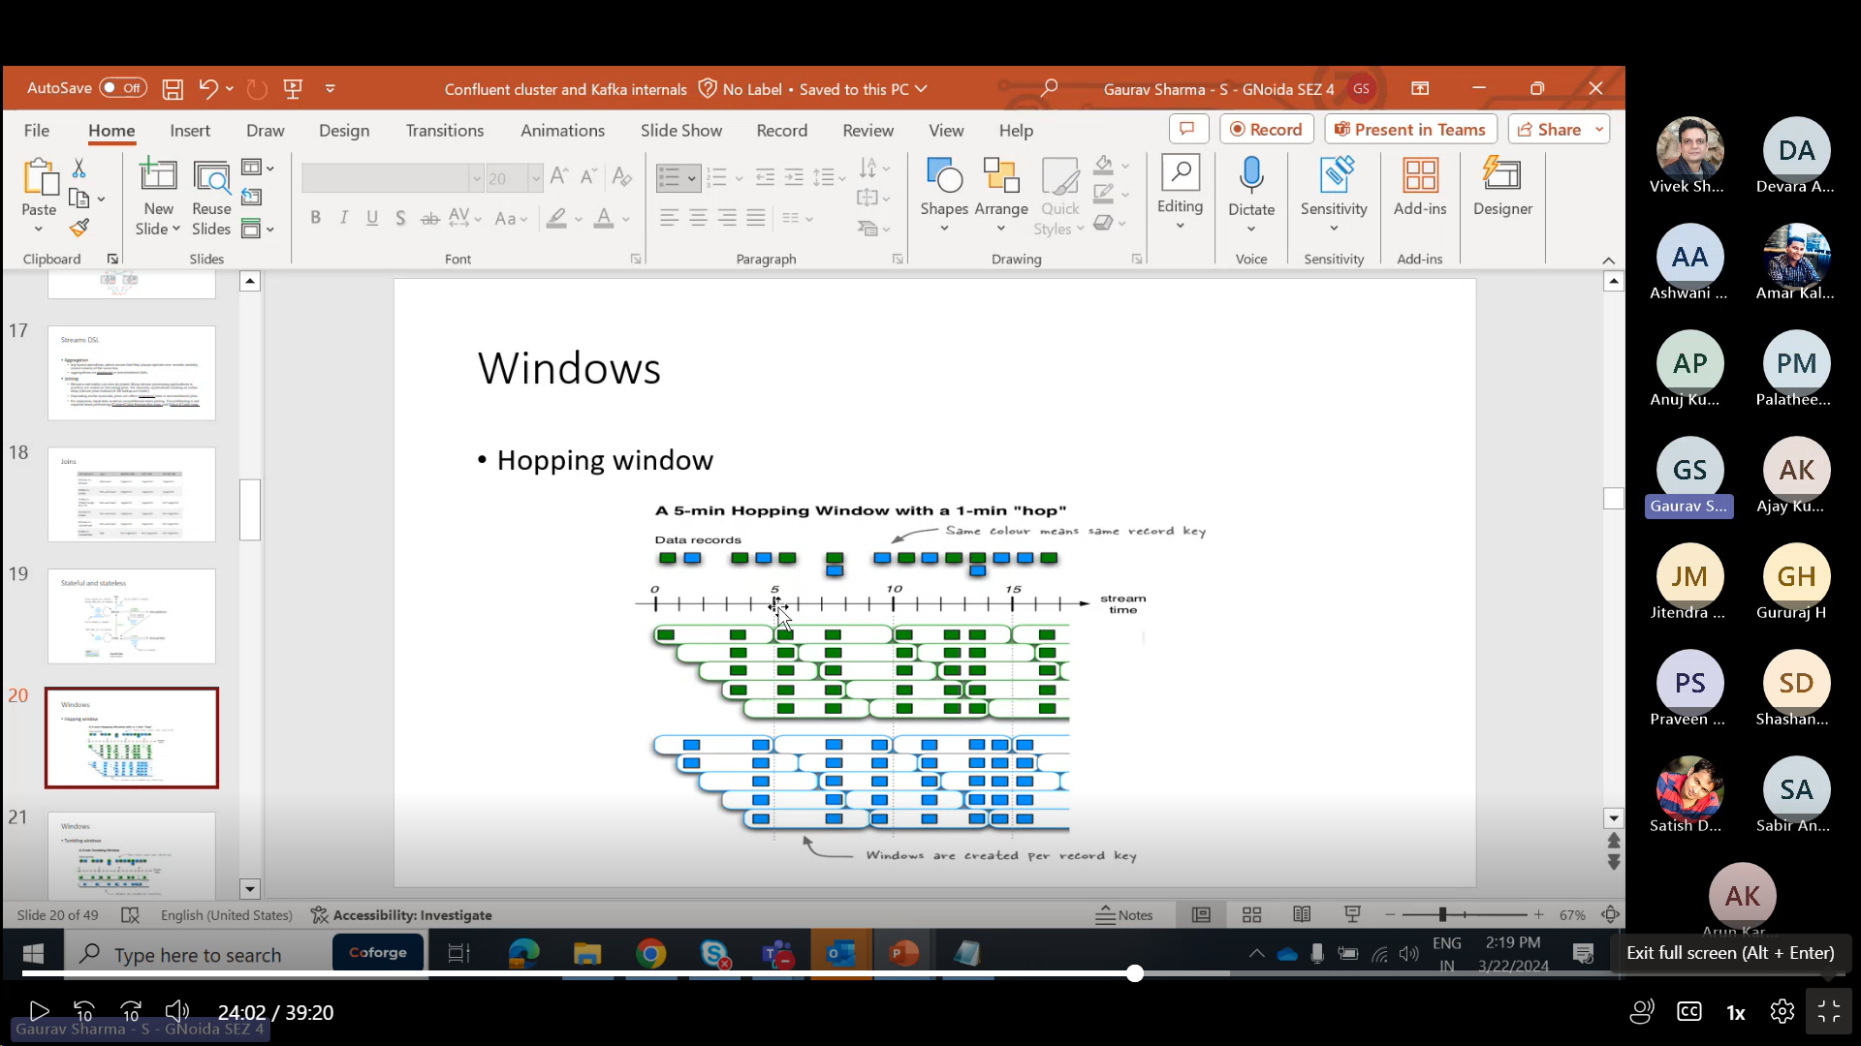

In hopping window 1 min Hop is there i.e window extends after each second.

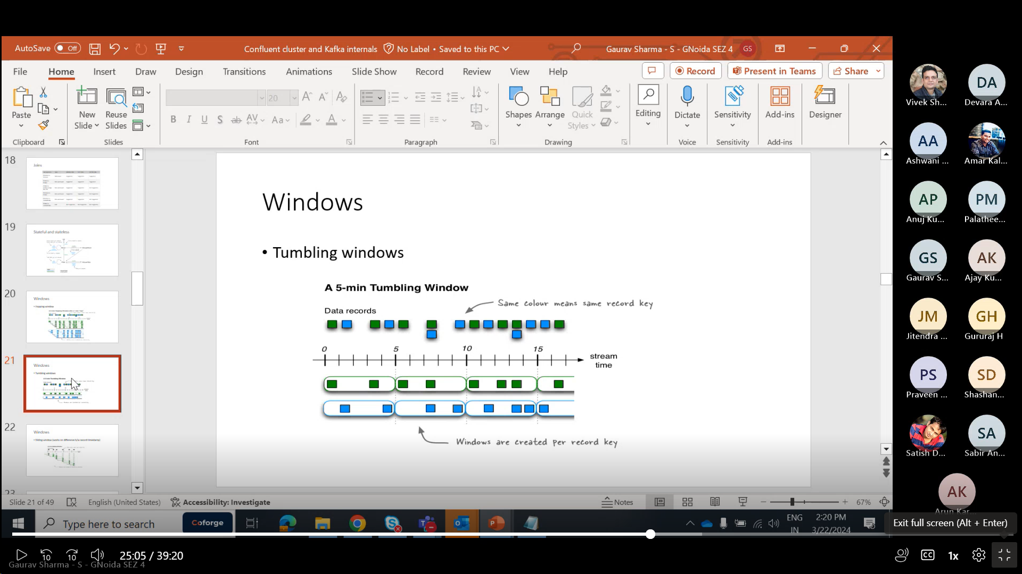

In tumbling window,one window is limited upto 5 min and another window starts after 5 min.

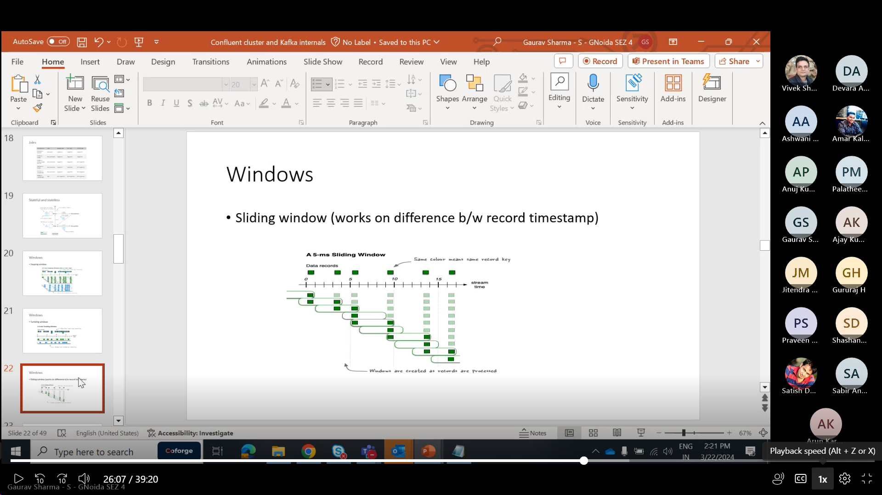

In Sliding window the duration is very small upto 5ms and window keep on sliding in small intervals.

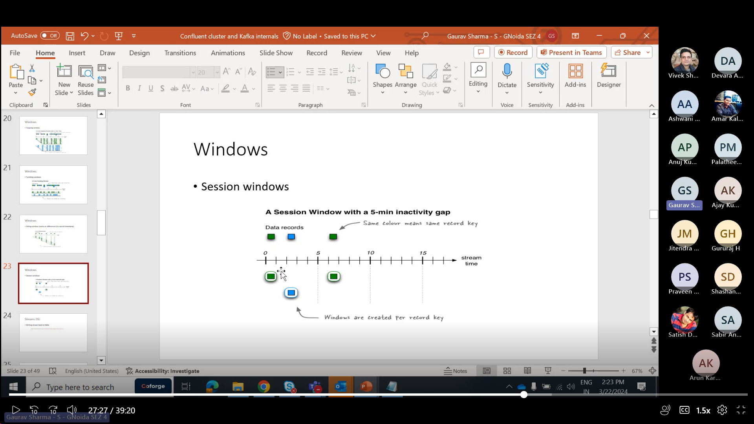

In Session windows,session will timeout due to inactivity for a particular time period.A new session will start after specific time.

Link:- <https://kafka.apache.org/20/documentation/streams/developer-guide/dsl-api.html#creating-source-streams-from-kafka>

KSQLdb:- <https://docs.ksqldb.io/en/latest/developer-guide/ksqldb-reference/>

Why is data co-partitioning required? Because [KStream-KStream](https://kafka.apache.org/20/documentation/streams/developer-guide/dsl-api.html" \l "streams-developer-guide-dsl-joins-kstream-kstream), [KTable-KTable](https://kafka.apache.org/20/documentation/streams/developer-guide/dsl-api.html" \l "streams-developer-guide-dsl-joins-ktable-ktable), and [KStream-KTable](https://kafka.apache.org/20/documentation/streams/developer-guide/dsl-api.html" \l "streams-developer-guide-dsl-joins-kstream-ktable) joins are performed based on the keys of records (e.g., leftRecord.key == rightRecord.key), it is required that the input streams/tables of a join are co-partitioned by key.

Create and verify a topic:

# /usr/local/kafka/bin/kafka-topics.sh --bootstrap-server localhost:9092 -- create --replication-factor 1 --partitions 1 --topic test Created topic "test". # /usr/local/kafka/bin/kafka-topics.sh --bootstrap-server localhost:9092 --describe --topic test

Produce messages to a test topic (use Ctrl-C to stop the producer at any time):

# /usr/local/kafka/bin/kafka-console-producer.sh --bootstrap-server localhost:9092 --topic test

Consume messages from a test topic:

# /usr/local/kafka/bin/kafka-console-consumer.sh --bootstrap-server localhost:9092 --topic test --from-beginning

he appropriate size for a Kafka cluster is determined by several factors. Typically, the size of your cluster will be bound on the following key areas:

• Disk capacity

• Replica capacity per broker

• CPU capacity

• Network capacity

In this configuration, the initLimit is the amount of time to allow followers to con‐ nect with a leader. The syncLimit value limits how long out-of-sync followers can be with the leader.

The servers are specified in the format server.X=hostname:peer Port:leaderPort, with the following parameters

peerPort :The TCP port over which servers in the ensemble communicate with one another

leaderPort: The TCP port over which leader election is performed.

auto.create.topics.enable: it automatically creates the topic in a broker in multiple scenarios .

When a producer starts writing messages to the topic • When a consumer starts reading messages from the topic • When any client requests metadata for the topic

delete.topic.enable :Depending on your environment and data retention guidelines, you may wish to lock down a cluster to prevent arbitrary deletions of topics. Disabling topic deletion can be set by setting this flag to false.

auto.leader.rebalance.enable :In order to ensure a Kafka cluster doesn’t become unbalanced by having all topic leadership on one broker, this config can be specified to ensure leadership is balanced as much as possible. It enables a background thread that checks the distribution of partitions at regular intervals

## Garbage Collector In Apache Kafka

Tuning the Java garbage-collection options for an application has always been some‐ thing of an art, requiring detailed information about how the application uses mem‐ ory and a significant amount of observation and trial and error. Thankfully, this has changed with Java 7 and the introduction of the Garbage-First garbage collector (G1GC). While G1GC was considered unstable initially, it saw marked improvement in JDK8 and JDK11. It is now recommended for Kafka to use G1GC as the default garbage collector. G1GC is designed to automatically adjust to different workloads and provide consistent pause times for garbage collection over the lifetime of the application. It also handles large heap sizes with ease by segmenting the heap into smaller zones and not collecting over the entire heap in each pause. 42 | Chapter 2: Installing Kafka G1GC does all of this with a minimal amount of configuration in normal operation. There are two configuration options for G1GC used to adjust its performance:

1)MaxGCPauseMillis-Garbage collection at regular intervalsd

2)InitiatingHeapOccupancyPercent-This means that G1GC will not start a collection cycle until after 45% of the heap is in use.

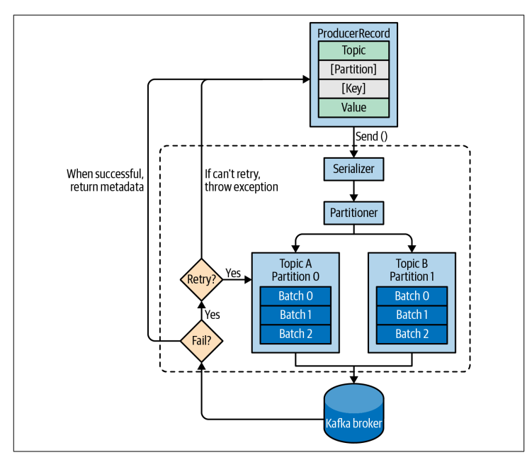

acks=0 The producer will not wait for a reply from the broker before assuming the mes‐ sage was sent successfully. This means that if something goes wrong and the broker does not receive the message, the producer will not know about it, and the message will be lost. However, because the producer is not waiting for any response from the server, it can send messages as fast as the network will support, so this setting can be used to achieve very high throughput.

acks=1 The producer will receive a success response from the broker the moment the leader replica receives the message. If the message can’t be written to the leader (e.g., if the leader crashed and a new leader was not elected yet), the producer will receive an error response and can retry sending the message, avoiding potential loss of data. The message can still get lost if the leader crashes and the latest mes‐ sages were not yet replicated to the new leader.

acks=all The producer will receive a success response from the broker once all in sync replicas receive the message. This is the safest mode since you can make sure more than one broker has the message and that the message will survive even in case of a crash (more information on this in Chapter 6). However, the latency we discussed in the acks=1 case will be even higher, since we will be waiting for more than just one broker to receive the message.

The default produce and consume quotas that are applied to all clients are part of the Kafka broker configuration file. For example, to limit each producer to send no more than 2 MBps on average, add the following configuration to the broker configuration file: quota.producer.default=2M.

To allow clientA to produce 4 MBps and clientB 10 MBps, you can use the following: quota. producer.override="clientA:4M,clientB:10M

# Streams DSL-

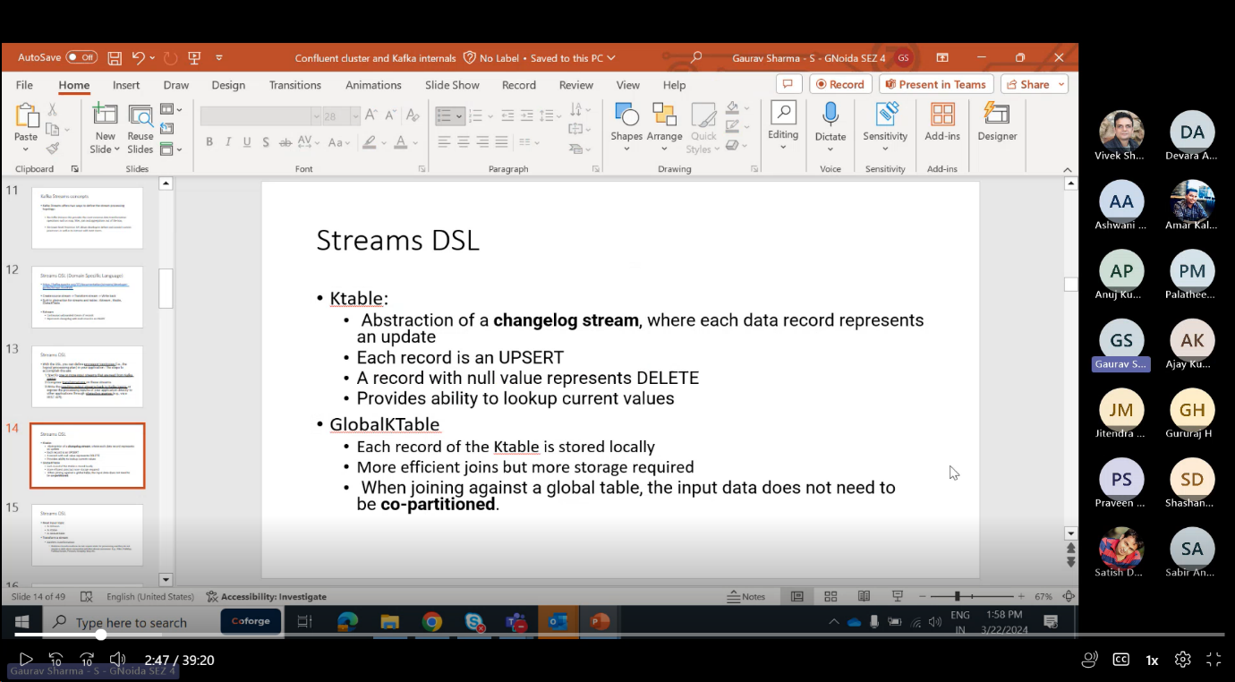KTable-

1)Abstraction of a change log stream,each record represents an update

2)Each record represent upsert.

3)Records with null value represents delete.

GlobalKTable-

1)Each record KTable is stored locally

2)More efficient joins,more storage required.

3)input data need not to be co-partitioned.

4)it is memory intensive.

We can read the topic in many forms KStream🡪topic

KStream → KStream[]

* Branch (or split) a KStream based on the supplied predicates into one or more KStream instances. ([details](https://kafka.apache.org/20/javadoc/org/apache/kafka/streams/kstream/KStream.html#branch-org.apache.kafka.streams.kstream.Predicate...-))
* Predicates are evaluated in order. A record is placed to one and only one output stream on the first match: if the n-th predicate evaluates to true, the record is placed to n-th stream. If no predicate matches, the the record is dropped.

KStream → KStream

* KTable → KTable

Evaluates a boolean function for each element and retains those for which the function returns true. ([KStream details](https://kafka.apache.org/20/javadoc/org/apache/kafka/streams/kstream/KStream.html" \l "filter-org.apache.kafka.streams.kstream.Predicate-), [KTable details](https://kafka.apache.org/20/javadoc/org/apache/kafka/streams/kstream/KTable.html" \l "filter-org.apache.kafka.streams.kstream.Predicate-))

**Grouping vs. Windowing:** A related operation is [windowing](https://kafka.apache.org/20/documentation/streams/developer-guide/dsl-api.html#streams-developer-guide-dsl-windowing), which lets you control how to “sub-group” the grouped records of the same key into so-called windows for stateful operations such as windowed [aggregations](https://kafka.apache.org/20/documentation/streams/developer-guide/dsl-api.html#streams-developer-guide-dsl-aggregating) or windowed [joins](https://kafka.apache.org/20/documentation/streams/developer-guide/dsl-api.html#streams-developer-guide-dsl-joins).

Stateful transformations depend on state for processing inputs and producing outputs and require a [state store](https://kafka.apache.org/20/documentation/streams/architecture.html#streams_architecture_state) associated with the stream processor. For example, in aggregating operations, a windowing state store is used to collect the latest aggregation results per window.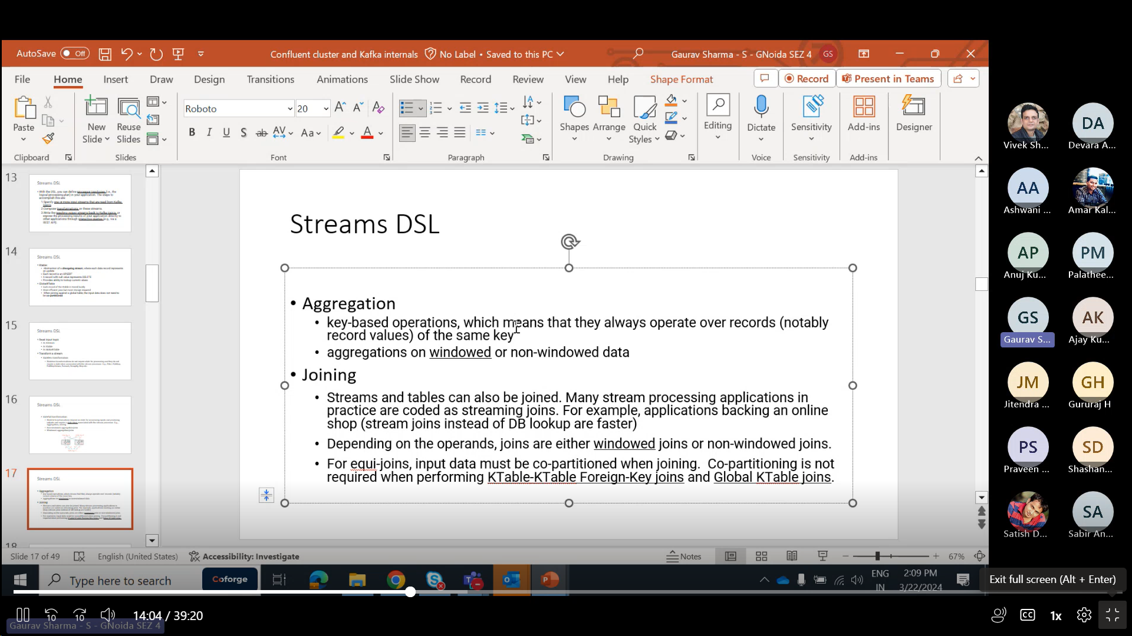

#### [Joining](https://kafka.apache.org/20/documentation/streams/developer-guide/dsl-api.html#id13)

Streams and tables can also be joined. Many stream processing applications in practice are coded as streaming joins. For example, applications backing an online shop might need to access multiple, updating database tables (e.g. sales prices, inventory, customer information) in order to enrich a new data record (e.g. customer transaction) with context information. That is, scenarios where you need to perform table lookups at very large scale and with a low processing latency. Here, a popular pattern is to make the information in the databases available in Kafka through so-called change data capture in combination with [Kafka’s Connect API](https://kafka.apache.org/20/documentation/#connect), and then implementing applications that leverage the Streams API to perform very fast and efficient local joins of such

KStream to KStream applications require Co-Partitioning🡪

Suppose,

Topic A:2 partitions

Topic B:2 Partitions

K1->Topic A::partition 0

K1->Topic B::partition 0

Key 1

And that concept is copartitioning. So let's say we have our two strings from two different topics, so both our topics should have each same number of partitions, OK? And the partition assignment strategy also should be same only then two streams can be joined. Why? Because let's say for example we we are running a stream application, OK and let's say.

Topic.

He has two partitions.

OK, topic B has.

I think we has, let's say again 2 partitions.

So what happens is, you know.

A record with same key, a record with the key will go to same partition all the time. So we are publishing let's say P.

OK, so this record will always go to same partition message when goes to partition.

Zero.

So this also has to go to partition 0. Why? Because because what happens is whenever we are running the stream application, right? So let's say two tasks are created, 2 instances are created internally it will it will just create the task OK and each task will handle one partition. So these ports should go to same task only then join can happen. OK so keep is joined right? So we need to have the same keys available to the same task.

And then only it can do a join and it can also.

Store it in the local state stores OK state store will contain the local state of the. It will contain the state of the stream. OK, so that means it it needs to have the key same keys all the time. OK.

And so partition, number of partition and partition assignment strategy has to be same for both the topics. So that means case into K string requires 4 partitioned topics.

KStream To KStream require Co-partitioned topics.

Security Protocol-

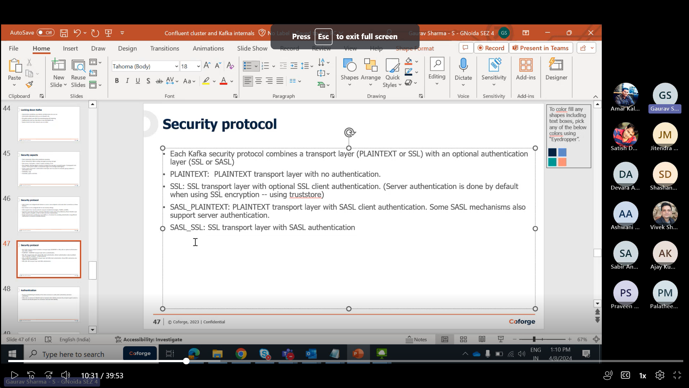

SASL\_SSL means we are doing authentication using SASL and encryption using SSL i.e .

Kafka Uses principal of authorisation ,access and authencity ,we are proving Principal In Kerberos.

OK, so let's say you are using sasl SSL.

Gaurav Sharma - S - GNoida SEZ 4 15 minutes

OK, in this case what happens is you're authentication is happening with sassel.

Gaurav Sharma - S - GNoida SEZ 4 15 minutes 5 seconds

OK.

Gaurav Sharma - S - GNoida SEZ 4 15 minutes 6 seconds

But there will be server authentication happening with SSL because whenever we want to send any message or we want to consume a new message we have to do the encryption OK and by default as I said we'll do the server AUTHENTICATION OK and only then it will get the keys for encryption OK whenever we are using security protocol so system and making client authentication as required.

Gaurav Sharma - S - GNoida SEZ 4 15 minutes 33 seconds

OK, that time both are authentication as well as encryption will happen using SSL.

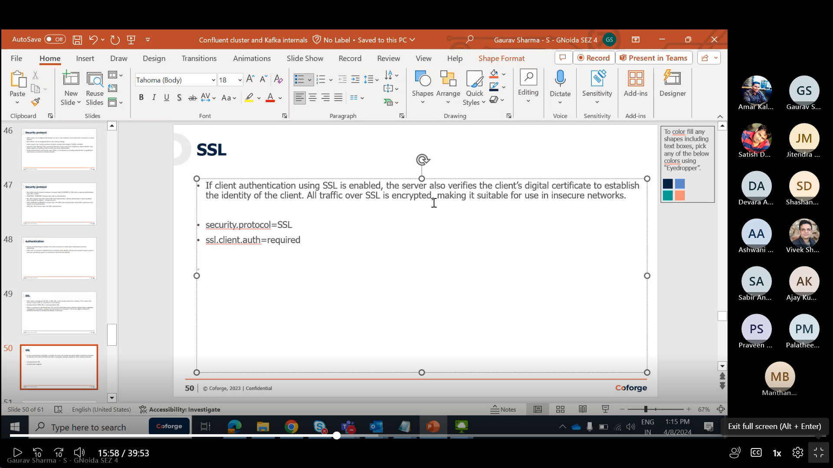

SSLtruststorelocation:it is file stored in specific location.it is used to authenticate the server.

If we set ssl.client.auth=required as in pic abov then we also have to maintain keystore to authenticate client.broker will request client for authentication and for that we have to maintain Keystore.

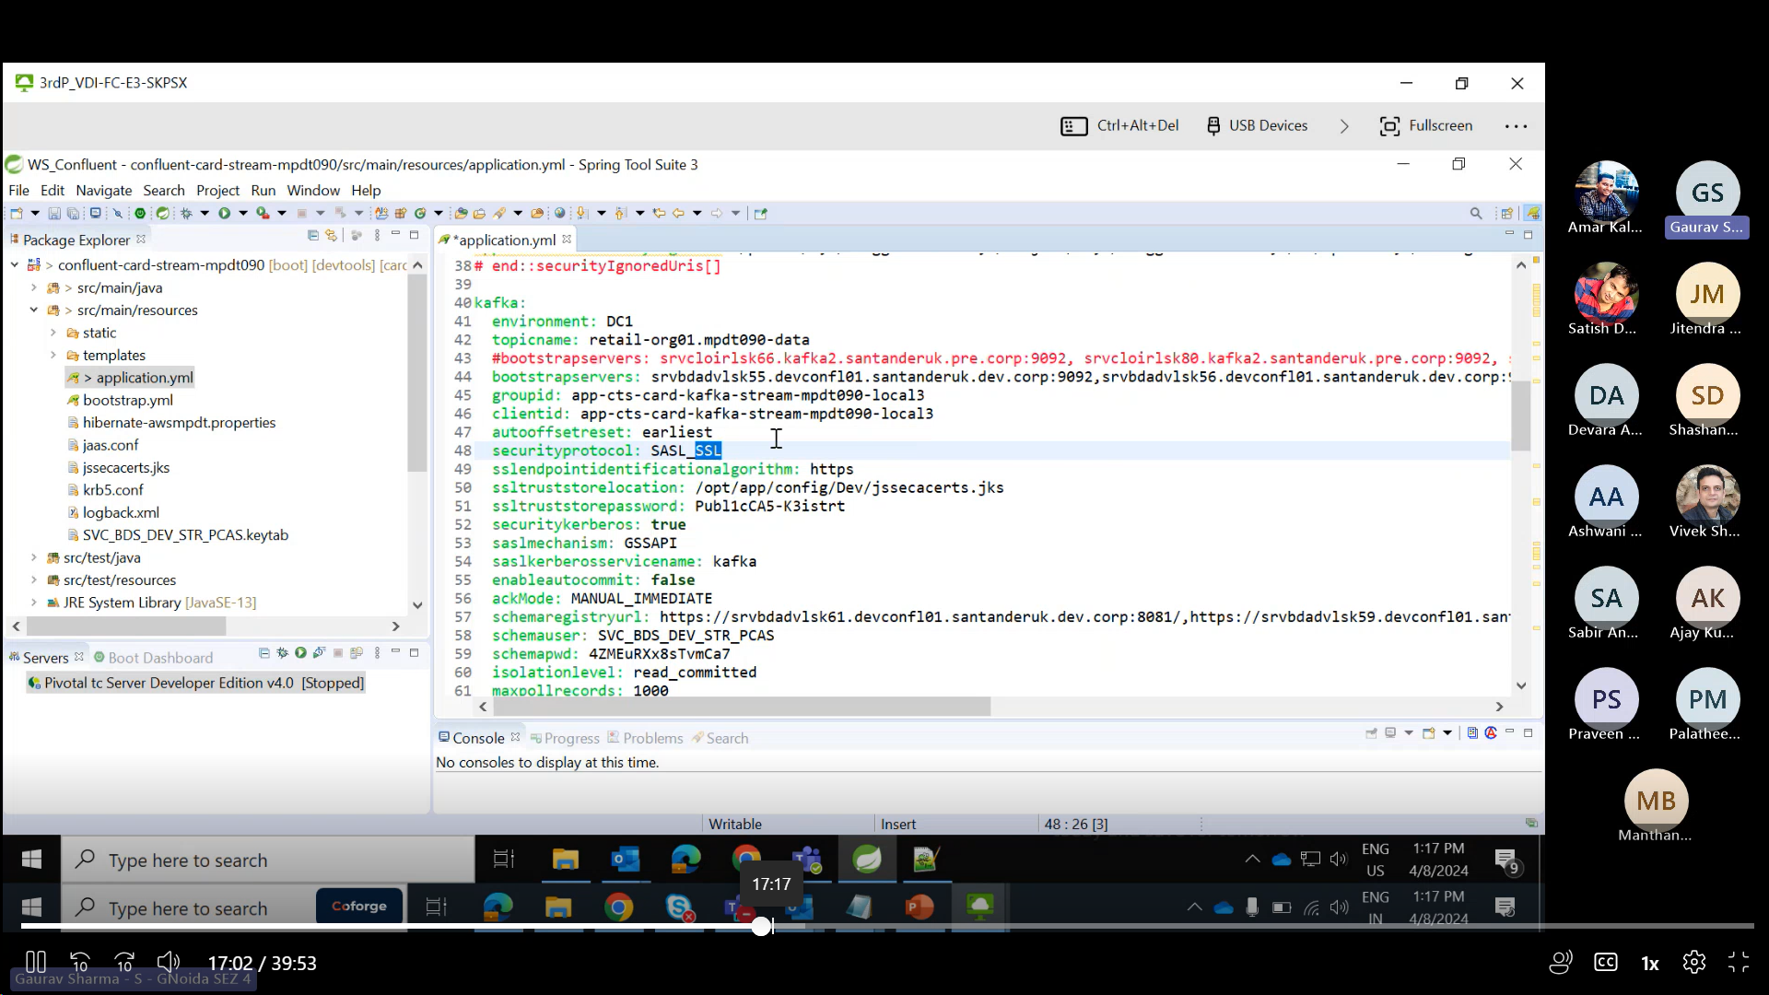

For SASL\_SSL,no client authentication,client authentication is for SaSl only .

# KStream to KStream joins-

Meaning that all tuples close to each other with regard to time are joined.Time here is difference to size of window.

These joins are always windowed joins because otherwise, the size of the internal state store used to perform the join would grow indefinitely.

KStream-KStream Join is always windowed joins, we must provide a join window.

KStream<String, String> joined = left.join(right,

(leftValue, rightValue) -> "left=" + leftValue + ", right=" + rightValue, /\* ValueJoiner \*/

JoinWindows.of(TimeUnit.MINUTES.toMillis(5)),

Serdes.String(), /\* key \*/

Serdes.Long(), /\* left value \*/

Serdes.Double() /\* right value \*/

);

## KTable to KTable Joins-

Are designed to consistent with their counterparts in relational databases. they are always non-windowed joins.

The changelog streams of KTables is materialized into local state stores that represent the latest snapshot of their tables. The join result is a new KTable representing changelog stream of the join operation.

The join here is key-based — that is, leftRecord.key == rightRecord.key — and will be automatically triggered everytime a new input is received.

KTable<String, String> joined = left.join(right,

(leftValue, rightValue) -> "left=" + leftValue + ", right=" + rightValue /\* ValueJoiner \*/

);

## KSTREAM to KTABLE joins-

They allow you to perform table lookups against a KTable everytime a new record is received from the KStream.

The KTable lookup is always done on the current state of the KTable; thus, out-of-order records can yield a non-deterministic result. The result of a KStream-KTable join is a KStream.

KStream<String, String> joined = left.join(right,

(leftValue, rightValue) -> "left=" + leftValue + ", right=" + rightValue, /\* ValueJoiner \*/

Serdes.String(), /\* key \*/

Serdes.Long() /\* left value \*/

);

SASL (Simple Authentication Security Layer) is a framework that provides developers of applications and shared libraries with mechanisms for authentication, data integrity-checking, and encryption.

* [SASL using JAAS](https://docs.confluent.io/platform/current/kafka/authentication_sasl/index.html#kafka-sasl-auth)

Kafka uses the Java Authentication and Authorization Service (JAAS) for SASL configuration. You must provide JAAS configurations for all SASL authentication mechanisms. This topic explains how to configure JAAS for SASL.

* [SASL/GSSAPI (Kerberos)](https://docs.confluent.io/platform/current/kafka/authentication_sasl/authentication_sasl_gssapi.html#kafka-sasl-auth-gssapi)

SASL/GSSAPI uses your Kerberos or Active Directory server for authentication.

* [SASL/OAUTHBEARER](https://docs.confluent.io/platform/current/kafka/authentication_sasl/authentication_sasl_oauth.html#cp-oauth-authentication)

Only suitable for use in non-production Kafka installations, SASL/OAUTHBEARER enables the use the OAuth 2 Authorization framework in a SASL context to create and validate unsecured JSON web tokens for authentication.

* [SASL/PLAIN](https://docs.confluent.io/platform/current/kafka/authentication_sasl/authentication_sasl_plain.html#kafka-sasl-auth-plain)

SASL/PLAIN uses a simple username and password for authentication.

* [SASL/SCRAM](https://docs.confluent.io/platform/current/kafka/authentication_sasl/authentication_sasl_scram.html#kafka-sasl-auth-scram)

SASL/SCRAM uses usernames and passwords stored in ZooKeeper. Credentials are created during installation.

BufferExhaustedException:-

This exception is thrown if the producer cannot allocate memory for a record within max.block.ms due to the buffer being too full. In earlier versions a TimeoutException was thrown instead of this.

12. Consumer failed to process record # 10 and succeeded in processing record # 11. Select the course of action that you should choose to guarantee at least once processing

b) Do not commit until successfully processing the record at offset 10

You have a Zookeeper cluster that needs to be able to withstand the loss of 2 servers and still be able to function. What size should your Zookeeper cluster have?

1. 2 b) 5 c) 4 d) 6 e) 3

If any two servers fail, the ensemble can still function because a quorum can be formed out of the remaining three nodes. Thus, a five-node ZooKeeper ensemble can tolerate failure of up to two nodes.

Q=2N+1

Q=quorum

N=number of server failure that is needed to be handled.

rule "same key goes to the same partition" is true unless b) the number of partition changes

The rule "same key goes to the same partition" is true unless... Increasing the number of partition causes new messages keys to get hashed differently, and breaks the guarantee "same keys goes to the same partition". Kafka logs are immutable and the previous messages are not re-shuffled.

24.) To read data from a topic, the following configuration is needed for the consumers

a) any broker to connect to, and the topic name

### **auto.leader.rebalance.enable-**

means leader rebalance will automatically happen if leader is unstable. Enables auto leader balancing. A background thread checks the distribution of partition leaders at regular intervals, configurable by leader.imbalance.check.interval.seconds. If the leader imbalance exceeds leader.imbalance.per.broker.percentage, leader rebalance to the preferred leader for partitions is triggered.

26)A producer is sending messages with null key to a topic with 6 partitions using the DefaultPartitioner. Where will the messages be stored?

1) Any of the topic partitions

27)A consumer sends a request to commit offset 2000. There is a temporary communication problem, so the broker never gets the request and therefore never responds. Meanwhile, the consumer processed another batch and successfully committed offset 3000. What should you do?

Nothing, , it is displaying the same message.In the case of rebalance, this will cause more duplicates.

32. The Controller is a broker that is... (select two)

a) elected by broker majority

b) is responsible for consumer group rebalances

c) is responsible for partition leader election

d) elected by Zookeeper ensemble

c,d

34. Your priority for producing messages to the Kafka cluster is maximum throughput over low

latency. What would you do to accomplish this? (choose one)

a. Set batch.size low value and linger.ms to 0

b. Set batch.size high value and linger.ms to 0

c. Set batch.size low value and linger.ms to high value

d. Set batch.size high value and linger.ms to high value

d)The throughput is records processed per second,Latency is wait time befor process starts.

35. Your Kafka cluster consists of 3 brokers. You have 4 producer clients sending messages to the

“driver” topic which currently has 12 partitions and the related produce requests are receiving

timeout exceptions. What would you do to reduce these exceptions? (choose one)

Ans)TimeoutException comes when particular broker is overloaded with records ,so we need

another brokers to work upon it.

Use of Kafka Connectors

Connectors and tasks are logical units of work that run as a process. The process is called a worker in Kafka Connect. There are two modes for running workers:

* **Standalone mode**: Useful for development and testing Kafka Connect on a local machine. It can also be used for environments that typically use single agents (for example, sending web server logs to Kafka).
* **Distributed mode**: Distributed mode is recommended for production environments because of scalability, high availability, and management benefits. It runs Connect workers on multiple machines (nodes), which form a Connect cluster. Kafka Connect distributes running connectors across the cluster. You can add or remove nodes as your needs evolve.

59. There are five brokers in a cluster, a topic with 10 partitions and replication factor of 3, and a quota of producer\_bytes\_rate of 1 MB/sec has been specified for the client. What is the maximum throughput allowed for the client?

a) 0.33 MB/s

b) 5 MB/s

c) 10 MB/s

d) 1 MB/s

b) Each producer is allowed to produce @ 1MB/s to a broker. Max throughput 5 \* 1MB, because we have 5 brokers.

A Zookeeper configuration has tickTime of 2000, initLimit of 20 and syncLimit of 5. What's the timeout value for followers to connect to Zookeeper?

**A**20 sec

**B**10 sec

**C**2000 ms

**D**40 sec

tick time is 2000 ms, and initLimit is the config taken into account when establishing a connection to Zookeeper, so the answer is 2000 \* 20 = 40000 ms = 40s

What's a Kafka partition made of?

**A**One file and one index

**B**One file

**C**One file and two indexes per segment

**D**One file and two indexes

Kafka partitions are made of segments (usually each segment is 1GB), and each segment has two corresponding indexes (offset index and time index)

**Tick-Time**: used by zookeper to do heartbeats. session timeout is double the TickTime.

**initLimit**: is timeouts that zookeeper, used to limit the time that Zookeeper servers which are already in quorum have to connect to a leader.

 entry **syncLimit** limits how far out of date a server can be from a leader.

* **tickTime** : the basic time unit in milliseconds used by ZooKeeper. It is used to do heartbeats and the minimum session timeout will be twice the tickTime.
* **dataDir** : the location to store the in-memory database snapshots and, unless specified otherwise, the transaction log of updates to the database.
* **clientPort** : the port to listen for client connections

## KSQLDB:-

Allows you to build stream processing applications using Apache Kafka with ease of building traditional applications on a relational database. Using SQL to define what you want to do rather than how, it is easy to build kafka-native apps for real time data,

ksqlDB is designed from the principle of simplicity. While many streaming architectures require a grab-bag of components pieced together from many projects, ksqlDB provides a single platform on which you can build streaming ETL and streaming applications, and all with just a single dependency—Apache Kafka.

Regardless of how we choose to store it later, much of the data that we work with in our systems begins life as part of an **unbounded event stream.**

Stream processing is a method of processing events in an event stream, as they are happening. It is distinct from batch processing, in which events are processed at some delayed point in time, after they are created. With stream processing, we can react to events happening in the real world when they occur, rather than afterwards.

With ksqlDB, we can apply this concept of stream processing using SQL. The ability to use SQL, unlike other options that require complex coding to perform even simple tasks, makes stream processing accessible to many more developers and analysts.

SELECT \*

FROM WIDGETS

WHERE WEIGHT\_G > 120

ksqlDB separates its distributed compute layer from its distributed storage layer, for which it uses Apache Kafka.

**ksqlDB allows us to read, filter, transform, or otherwise process streams and tables of events, which are backed by Kafka topics. We can also join streams and/or tables to meet the needs of our application. And we can do all of this using familiar SQL syntax**.

## Interacting with KSQLDB:-

## There are several ways to interact with ksqlDB, including a command line interface, a web UI, a REST API, and client libraries for Java and other languages.

## CLI:-

The ksqlDB CLI is very similar in look and feel to command line tools for relational databases that you may be familiar with, such as Postgres’s psql or Oracle’s SQL\*Plus:

## REST API:-

The [ksqlDB REST API](https://docs.ksqldb.io/en/latest/developer-guide/ksqldb-rest-api/" \t "_blank) provides programmatic access to ksqlDB for managing objects

Create Stream using ksqlDB cloud:-

CREATE STREAM MOVEMENTS (PERSON VARCHAR KEY, LOCATION VARCHAR)

WITH (VALUE\_FORMAT='JSON', PARTITIONS=1, KAFKA\_TOPIC='movements');

INSERT INTO MOVEMENTS VALUES ('Allison', 'Denver');

INSERT INTO MOVEMENTS VALUES ('Robin', 'Leeds');

INSERT INTO MOVEMENTS VALUES ('Robin', 'Ilkley');

INSERT INTO MOVEMENTS VALUES ('Allison', 'Boulder');

A company configured a Kafka cluster with the parameters  --log.retention.hours = 200,  --log.retention.minutes = 200 and --log.retention.ms = 200. With this configuration, how long will log data be retained before old log segments will be discarded to free up space?

1)200 MS.

If more than one similar config is specified, the **smaller unit size will take precedence**.

**log.retention.ms:** The number of milliseconds to keep a log file before deleting it (in milliseconds), If not set, the value in log.retention.minutes is used. If set to -1, no time limit is applied.

In case the consumer has the wrong leader of a partition, it will issue a **metadata request**. The Metadata request can be handled by any node, so clients know afterwards which broker are the designated leader for the topic partitions.

The response contains metadata for each partition, with partitions grouped together by topic:

- **Leader:** The node id of the Kafka broker currently acting as leader for this partition. If no leader exists because we are in the middle of a leader election this id will be -1.

- **Replicas:** The set of alive nodes that currently acts as slaves for the leader for this partition.

- **ISR:** The set subset of the replicas that are "caught up" to the leader.

- **Broker:** The node id, hostname, and port information for a Kafka broker.

**Note:** Produce and consume requests can only be sent to the node hosting **partition leader**.

ksqlDB has a limitation in that it **doesn't support structured keys**, preventing the creation of a stream from a windowed aggregate.

In practical scenarios, when working with windowed aggregates in ksqlDB, understanding the limitations related to structured keys is important for designing and implementing effective streaming applications.

Using ksqlDB, which of the following two options together allow you to use Avro data and integrate with Confluent Schema Registry?

To be able to use Avro data and integrate with Confluent Schema Registry you need to do the following two steps:

- Install the Confluent Schema Registry. This is included by default with Confluent Platform.

- Configure the ksql.schema.registry.url property in the ksqlDB server configuration to point to Schema Registry.

**Important Note:** Avro message values are supported. Avro keys are not yet supported.

In Kafka, the purpose of **describing** topics is to know the leader for the topic, the broker instances acting as replicas for the topic, and the number of partitions of a Kafka topic that has been created with.

When describing Kafka topics you can set some additional properties to only show specific topics / partitions, e. g.:

## **--topics-with-overrides:** If set when describing topics, only show topics that have overridden configs.

**--unavailable-partitions:** If set when describing topics, only show partitions whose **leader is not available**.

**--under-min-isr-partitions:** If set when describing topics, only show partitions whose ISR count is less than the configured minimum.

**--under-replicated-partitions:** If set when describing topics, only show under replicated partitions.

To make your data fault-tolerant and highly-available, every Kafka topic can be **replicated**, so that there are always multiple brokers that have a copy of the data just in case things go wrong, you want to do maintenance on the brokers, and so on. A common production setting is a **replication factor of 3**, i. e., there will always be three copies of your data. This replication is performed at the level of topic-partitions.

If the replication factor is **4**, three brokers can be down (**replication factor - 1**) without impacting the topic availability.

At-least once guarantee means you will definitely receive and process every message, but you may process some messages additional times in the face of a failure.

For a consumer application **at-least once processing** means the consumer group receives a batch of messages from Kafka, transforms these and writes the results to a database. The consumer application has enable.auto.commit set to false and is programmed to commit their offsets back to Kafka **once the database write succeeds**. If the consumer fails after writing the data to the database but before saving the offsets back to Kafka, it will reprocess the same records next time it runs and save them to the **database once more**.

## KSQLDB:-

To configure ksqlDB to connect to a Kafka cluster over SSL with a user-supplied trust store, you set **security.protocol** to **SSL** and provide the trust store location and password.

To note:

* **ksqlDB can connect to an Apache Kafka cluster over TLS**
* **ksqlDB can connect to an Apache Kafka cluster over TLS and authenticate using SASL**
* **ksqlDB will work with an Apache Kafka cluster secured using Kafka ACLs**
* **ksqlDB will work with a HTTPS Confluent Schema Registry**
* **ksqlDB will work with Confluent Cloud**

By default, Kafka ships with no authentication. Which of the following authentication mechanisms and protocols can be used with the Confluent Platform to enable authentication for Kafka brokers?

1)mTLS

2)HTTP Basic AUTH

3)SASL/PLAIN

4)ACL’s

Confluent Platform supports the following **authentication mechanisms and protocols** for Kafka brokers:

**SASL:** SASL (Simple Authentication Security Layer) is a framework that provides developers of applications and shared libraries with mechanisms for authentication, data integrity-checking, and encryption

**mTLS:** With mTLS (mutual TLS) authentication–also known as "two-way authentication" – both Kafka clients and servers use TLS certificates to verify each other's identities to ensure that traffic is secure and trusted in both directions.

**HTTP Basic Auth:**You can use HTTP Basic Authentication to authenticate with the Admin REST APIs using a username and password pair, which are presented to the REST Proxy server using the Authorization HTTP header.

**SSL:** You can configure SSL for encryption, but you can also configure SSL for authentication using SSL certificates.

**Note:** ACLs (Access Control Lists) or used for **authorization**, not for **authentication**.

By default, the consumer is configured to auto-commit offsets. Using auto-commit gives you "**at least once**" delivery. In order to know where to pick up the work, the consumer will read the latest committed offset of each partition and continue from there. Automatic commits are convenient, but they don’t give developers enough control to avoid **duplicate messages**.

By setting auto.commit.offset=false, offsets will only be committed when the application explicitly chooses to do so. The simplest and most reliable of the commit APIs is **commitSync()**, but this will block the application until the broker responds to the commit request.

Another option is the asynchronous commit API **commitAsync()**, which will not block the application and not limit the throughput of the application.

**Using the configuration "replication.factor=3", "min.insync.replicas=2" and "acks=all", what happens if two brokers are down and a consumer group tries to consume from Kafka?**

In Kafka, producers create and write messages to topic partitions and consumers read data from these partitions.

With **acks=all** and a replication factor of 3 and two brokers are down, the minimum of in-sync replicas cannot be met. Therefore a producer would raise an exception (either **NotEnoughReplicas** or **NotEnoughReplicasAfterAppend**).

For a consumer though, it's still possible to read data from the remaining replica.

**Q) To produce messages with key-value delimiters to a Kafka topic, which two properties need to be set using the "kafka-console-producer" CLI?**

It is possible to define a **key-value delimiter** for the given producer instance. The delimiter can vary each time you run the tool. For example, if you run the tool with the delimiter set to - and then a second time using :, Kafka will know how to store the data. The first term is always stored as the key, the second as the value. As a result, when the data written this way is consumed, the keys and values are consumed irrespective of what delimiter was used when the records were written to the topic.

To produce messages with key-value delimiters, you need to set two properties, parse.key and key.separator. Both properties can be set with the --properties option:

1. bin/kafka-console-producer.sh --topic test\_topic --bootstrap-server 127.0.0.1:9092 --property parse.key=true --property key.separator=":"

**What limitation does ksqlDB have regarding structured keys and windowed aggregates?**

ksqlDB has a limitation in that it **doesn't support structured keys**, preventing the creation of a stream from a windowed aggregate.

In practical scenarios, when working with windowed aggregates in ksqlDB, understanding the limitations related to structured keys is important for designing and implementing effective streaming applications.

A Kafka producer has the retries property set to 2147483647 to resend any record whose send fails with a potentially transient error. Which of the following additional configurations could potentially change the ordering of records?

Configuring **retries** for a Kafka producer will cause the client to resend any record whose send fails with a potentially transient error. Note that this retry is no different than if the client resent the record upon receiving the error.

Allowing retries without setting max.in.flight.requests.per.connection to **1** will potentially change the ordering of records because if two batches are sent to a single partition, and the first fails and is retried but the second succeeds, then the records in the second batch may appear first.

**Note:** One exception is the configuration "**enable.idempotence=true**" which takes care of the out of ordering case on its own.

In Kafka, the purpose of **describing** topics is to know the leader for the topic, the broker instances acting as replicas for the topic, and the number of partitions of a Kafka topic that has been created with.

When describing Kafka topics you can set some additional properties to only show specific topics / partitions, e. g.:

**--topics-with-overrides:** If set when describing topics, only show topics that have overridden configs.

**--unavailable-partitions:** If set when describing topics, only show partitions whose **leader is not available**.

**--under-min-isr-partitions:** If set when describing topics, only show partitions whose ISR (In-sync Replica) count is less than the configured minimum.

**--under-replicated-partitions:** If set when describing topics, only show under replicated partitions.

Kafka Streams:-

Kafka Streams is a client library for building streaming applications and microservices, where the **input** and **output** data are stored in Kafka clusters.

The **reduce** functioncombines the values of (non-windowed) records by the grouped key (in the example the key is always 1). The current record value is combined with the last reduced value, and a new reduced value (in the example the sum) is returned.

The result is **aggregated into a table** with the sum as the value. We have to enable **log compaction** for this topic to align the topic's cleanup policy with KTable semantics.

#### PartitionStateChange:

Valid states are:

* NonExistentPartition: This state indicates that the partition was either never created or was created and then deleted.
* NewPartition: After creation, the partition is in the NewPartition state. In this state, the partition should have replicas assigned to it, but no leader/isr yet.
* OnlinePartition: Once a leader is elected for a partition, it is in the OnlinePartition state.
* OfflinePartition: If, after successful leader election, the leader for partition dies, then the partition moves to the OfflinePartition state.

## MultiThreaded Consumption with Kafka Consumer-

When implementing a multi-threaded consumer architecture, it is important to note that the Kafka consumer is not thread safe. Multi-threaded access must be properly synchronized, which can be tricky. This is why the single-threaded model is commonly used.

A typical single-threaded implementation is centered around a poll loop. Basically, it’s an infinite loop that repeats two actions:

1. Retrieving records using the poll() method
2. Processing fetched records

With the default configuration, the consumer automatically stores offsets to Kafka. You can use the auto.commit.interval.ms config to tweak the frequency of commits. The following is the official description of this [config](https://docs.confluent.io/current/installation/configuration/consumer-configs.html" \t "_blank):

the auto.commit.interval.ms only defines the minimum delay between commits. Only offsets of records returned in previous poll calls are committed. Since processing happens between poll calls, offsets of unprocessed records will never be committed.

Multithreading is the ability of a central processing unit (CPU) to provide multiple threads of execution concurrently, supported by the operating system. In situations where the work can be divided into smaller units, which can be run in parallel, without negative effects on data consistency, multithreading can be used to improve application performance.

When implementing a multi-threaded **consumer** architecture, it is important to note that the **Kafka consumer is not thread safe**. Multi-threaded access must be properly synchronized, which can be tricky. This is why the single-threaded model is commonly used.

The only exception to this rule is [wakeup()](https://kafka.apache.org/25/javadoc/org/apache/kafka/clients/consumer/KafkaConsumer.html#wakeup--), which can safely be used from an external thread to interrupt an active operation. In this case, a [WakeupException](https://kafka.apache.org/25/javadoc/org/apache/kafka/common/errors/WakeupException.html" \o "class in org.apache.kafka.common.errors) will be thrown from the thread blocking on the operation. This can be used to**shutdown the consumer from another thread**

With automatic offset commit enabled in the thread per consumer model, you don’t have to worry about group rebalancing. Everything is done by the poll method automatically. However, if you disable automatic offset commit and commit manually, it’s your responsibility to commit offsets before the join group request is sent. You can do this in two ways:

1. Always call commitSync() after fetched records are processed and before the next poll method call
2. Implement ConsumerRebalanceListener to get notified when partitions are about to be revoked, and commit corresponding offsets at that point

**What is the use of cardConsumerRebalanceListener?**

**It is used to check to notify when the partitions are going to be Revoked and it will commit the offsets at that particular point.**

## How to handle slow Records Processing:-

Link:- <https://www.confluent.io/de-de/blog/kafka-consumer-multi-threaded-messaging/>

The maximum delay allowed between poll method calls is defined by the max.poll.interval.ms config, which is five minutes by default. If a consumer fails to call the poll method within that interval, it is considered dead, and group rebalancing is triggered. This can happen often with the thread per consumer and default configuration for use cases where each record takes a long time to be processed.

When using the thread per consumer model, you can deal with this problem by tuning the following config values:

* Set max.poll.records to a smaller value
* Set max.poll.interval.ms to a higher value
* Perform a combination of both

When the record processing time varies, it might be hard to tweak these configs perfectly, so it is recommended to use separate threads for processing.

## **Handling record processing exceptions**

Record processing logic, including error handling, is application specific. In the case of processing errors, you can perform one of the following options:

* Stop processing and close the consumer (optionally, retry a few times beforehand)
* Send records to the dead letter queue and continue to the next record (optionally, retry a few times beforehand)
* Retry until the record is processed successfully (this might take forever)

## **Decoupling consumption and processing**

In a multi-threaded implementation, the main consumer thread delegates records processing to other threads.

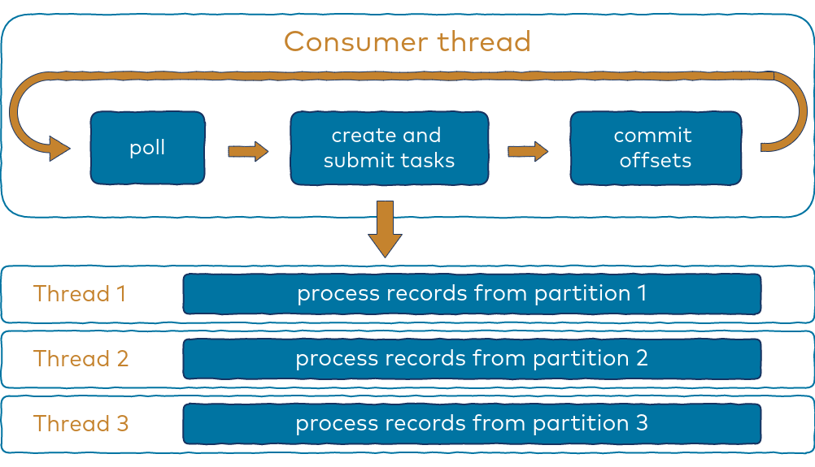

Records are retrieved using the poll method, the same as with a single-threaded implementation. Then, the records are grouped by partition, which results in multiple collections where each holds records from only a single partition. In order to process those collections, runnable tasks are created for each and submitted to an instance of Java’s built-in thread pool implementation.

The task implementation is quite simple, and the following represents a basic version that will be improved upon and discussed later in this blog post:

Copy

public class Task implements Runnable {

private final List records;

public Task(List records) {

this.records = records;

}

public void run() {

for (ConsumerRecord record : records) {

// do something with record

}

}

}

Note that the number of collections resulting from grouping by partition varies depending on the number of partitions assigned to a consumer, throughput, and some consumer configuration settings such as max.poll.records and max.partition.fetch.bytes.

Since records from each partition are processed sequentially, a low number of partitions can lead to underutilized CPU. If the number of partitions is very high, you don’t want to process all of them in parallel, since this would require a high number of threads.

In order to utilize the CPU efficiently, a thread pool with a fixed number of threads is used. That number is based on the number of available CPU cores as well as the nature of processing—is it CPU intensive or does it wait for I/O, etc.? For simplicity, assume eight core CPUs are used; therefore, a fixed thread pool with eight threads is configured:

Copy

private ExecutorService executor = Executors.newFixedThreadPool(8);

Tasks are submitted using the ExecutorService.submit() method, which returns immediately even if all the threads of the thread pool are currently in use. It simply adds a task to the thread pool’s internal queue where it waits to be processed.

After all of the tasks are submitted to the ExecutorService, the main consumer thread continues to poll for new records. The poll method is called frequently since there is not much to do between calls.

This means that there are no longer problems with excessive delays between poll method calls, and as a result, group rebalancing is very fast. Sounds great, right? But in order to maintain processing order and at-least-once delivery guarantees, some additional steps have to be taken.

----------------------------------------------------------------------------------------------

## What happens for a consumer application when closing one of the consumers cleanly?

The way consumers maintain membership in a consumer group and ownership of the partitions assigned to them is by sending **heartbeats**to a Kafka broker designated as the group coordinator(this broker can be different for different consumer groups). As long as the consumer is sending heartbeats at regular intervals, it is assumed to be alive, well, and processing messages from its partitions. Heartbeats are sent when the consumer **polls** (i. e., retrieves records) and when it **commits** records it has consumed.

When closing a consumer cleanly, the consumer will notify the group coordinator that it is leaving, and the group coordinator will trigger a rebalance immediately, reducing the gap in processing.

## Interaction from KSQLDB:-

There are several ways to interact with ksqlDB, including a **command line interface, a web UI, a REST API, and client libraries for Java and other languages**.

One of the simplest ways to interact with ksqlDB is via the web UI in Confluent Cloud. You can develop queries in an interactive editor, view flow diagrams of streams and tables, and manage persistent queries.

## **Handling group rebalances:-**

Since the poll method is now called in parallel with processing, the consumer could rebalance and some partitions might be reassigned to another consumer while there are still tasks processing records from those partitions. As a result, some records could be processed by both consumers.

Duplicate processing due to a group rebalance can be minimized by ensuring that the processing of records from revoked partitions is finished and corresponding offsets are committed before partitions get reassigned.

Passing an instance of ConsumerRebalanceListener as an argument to the KafkaConsumer.subscribe() method is a way to plug into the rebalance process and intercept partition revocation by implementing the ConsumerRebalanceListener‘s onPartitionsRevoke() method.

It is called from the consumer’s poll method, which means that this happens on the main consumer thread, so consumer.commitSync() can be called here without fear of running into the ConcurrentModificationException.

If there are tasks currently processing records from partitions that are being revoked, there are two options to handle this situation:

1. Wait for the task to finish
2. Stop the task, waiting only for the record currently being processed to finish

After that, offsets for those partitions can be committed.

Waiting results in the onPartitionsRevoked() method blocking the main consumer thread, so be aware that waiting too long might exceed the max.poll.interval.ms, causing the consumer to leave the group. Given this, the second option is better, since it takes less time.

Even with this option, the consumer may be kicked out of the group if processing a single record takes too long. This is most likely to happen when processing involves communication with an external system. To prevent that from happening, timeout on the external request should be smaller than max.poll.interval.ms.

If a timeout happens, the corresponding offset should not be committed, since the request won’t be considered successful. This means that the record will be processed again after the partition gets reassigned, which could produce duplicates in the external system, unless writes are idempotent.

# Start-Stop Synchronization-

As a result of group rebalancing, some tasks might be stopped even before the thread pool starts to process it, i.e., while they are still in the queue. That’s why start-stop synchronization is needed at the beginning of the run() method as well as at the end of the stop() method.

The stop() method sets the stopped flag to true, causing the processing loop to break on the next iteration (if the task processing is in progress). If the task is still in the queue, the stop()method immediately marks the task as completed.

The waitForCompletion() method waits for task completion by calling the get() method on the CompletableFuture instance. It can be completed in two ways:

1. From the run() method after the processing loop has finished
2. From the stop() method if it is called before the ExecutorService starts to process this task

### Conclusion-

Implementing a multi-threaded consumer model offers significant advantages over the thread per consumer model for certain use cases. Although there are many ways to do this, the key considerations are always the same:

* Ensure that records from the same partitions are processed only by one thread at a time
* Commit offsets only after records are processed
* Handle group rebalancing properly

Q) Which Kafka metric could be used if there is a lot of load on the system and you want to figure out what could be the problem for lag spikes?

The Confluent Control Center monitors a lot of important operational broker metrics aggregated across the cluster, and per broker or per topic where applicable.

The metric UnderReplicatedPartitionsmonitors the number of partitions that have problems with the **ISR** (in-sync replicas). Replicas that are added as part of a reassignment will not count toward this value. Alert if value is greater than 0.

UnderReplicatedPartitions means that data is not being replicated to enough number of brokers thereby increasing the probability of data loss should those replicas fail or die.

If you have under replicated partitions, it typically points to a problem with one or more brokers and you are having a **lot of load on the system**. You should root cause the problem immediately to avoid any data loss.

In Kafka Streams, what is the key distinction between the **map**, **foreach**, and **peek** operations?

The three methods map, peek, and foreach are quite similar to each other. In some sense, peek and foreach are but variants of map.

An important reason for explicit support of all three is that it allows a developer to clearly communicate the intent of an operation:

* map: “When I use map, my intent is to **modify** the input stream and **continue processing** the (modified) output, i.e. I want to create an output stream that contains the modified data so that I can perform additional operations on the modified data.”
* foreach: “When I use foreach, my intent is to **cause some side effects** based on the (unmodified) input stream and then I want to **terminate the processing**.” That’s why foreach returns void and thus is labeled as a terminal operation.
* peek: “When I use peek, my intent is to **cause some side effects** based on the (unmodified) input data and then I want to **continue the processing** of the (unmodified) input data.”

The Kafka project includes a tool called MirrorMaker, used for replicating data to other clusters. At its core, MirrorMaker is simply a Kafka consumer and producer, linked together with a queue. Messages are consumed from one Kafka cluster and produced to another. Figure 1-8 shows an example of an architecture that uses Mir‐ rorMaker, aggregating messages from two local clusters into an aggregate cluster and then copying that cluster to other datacenters. The simple nature of the application belies its power in creating sophisticated data pipelines, which will be detailed further

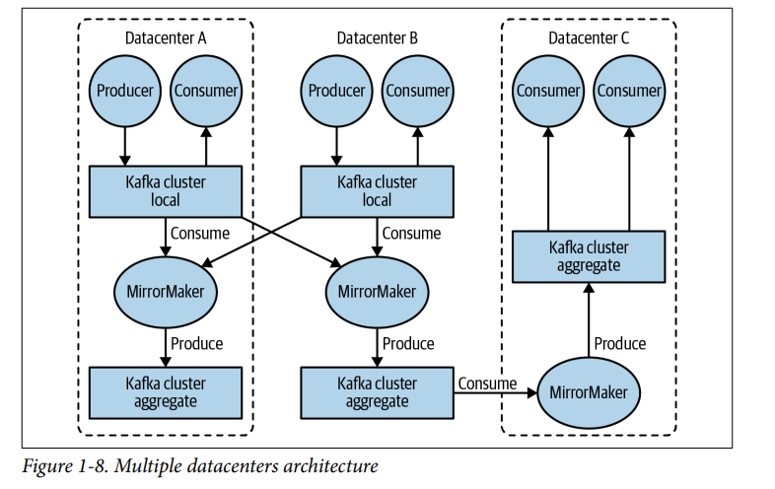

# Kafka Producer-

• Time until an async call to send() returns. During this interval, the thread that called send() will be blocked.

• From the time an async call to send() returned successfully until the callback is triggered (with success or failure). This is the same as from the point a Produce Record was placed in a batch for sending until Kafka responds with success, non‐ retriable failure, or we run out of time allocated for sending. If you use send() synchronously, the sending thread will block fo

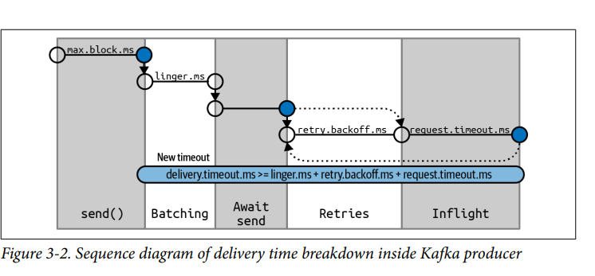

## request.timeout.ms

This parameter controls how long the producer will wait for a reply from the server when sending data. Note that this is the time spent waiting on each producer request before giving up; it does not include retries, time spent before sending, and so on. If the timeout is reached without reply, the producer will either retry sending or com‐ plete the callback with a TimeoutException

## retries and retry.backoff.ms-

When the producer receives an error message from the server, the error could be transient (e.g., a lack of leader for a partition). In this case, the value of the retries parameter will control how many times the producer will retry sending the message before giving up and notifying the client of an issue. By default, the producer will wait 100 ms between retries, but you can control this using the retry.backoff.ms parameter

## max.in.flight.requests.per.connection-

This controls how many message batches the producer will send to the server without receiving responses. Higher settings can increase memory usage while improving throughput.

## enable.idempotence-

Suppose you configure your producer to maximize reliability: acks=all and a decently large delivery.timeout.ms to allow sufficient retries. These make sure each message will be written to Kafka at least once.

Enabling idempotence requires max.in.flight.requests.per. connection to be less than or equal to 5, retries to be greater than 0, and acks=all. If incompatible values are set, a ConfigException will be thrown

# CardConsumerRebalanceListener-

**public void onPartitionsAssigned(Collection partitions)** Called after partitions have been reassigned to the consumer but before the con‐ sumer starts consuming messages. This is where you prepare or load any state that you want to use with the partition, seek to the correct offsets if needed, or similar. Any preparation done here should be guaranteed to return within max.poll.timeout.ms so the consumer can successfully join the group.

**public void onPartitionsRevoked(Collection partitions)** Called when the consumer has to give up partitions that it previously owned— either as a result of a rebalance or when the consumer is being closed. In the common case, when an eager rebalancing algorithm is used, this method is invoked before the rebalancing starts and after the consumer stopped consuming messages. If a cooperative rebalancing algorithm is used, this method is invoked at the end of the rebalance, with just the subset of partitions that the consumer has to give up. This is where you want to commit offsets, so whoever gets this partition next will know where to start.

**public void onPartitionsLost(Collection partitions)** Only called when a cooperative rebalancing algorithm is used, and only in excep‐ tional cases where the partitions were assigned to other consumers without first being revoked by the rebalance algorithm (in normal cases, onPartitions Revoked() will be called). This is where you clean up any state or resources that are used with these partitions. Note that this has to be done carefully—the new owner of the partitions may have already saved its own state, and you’ll need to avoid conflicts. Note that if you don’t implement this method, onPartitions Revoked() will be called instead

**If you implemented all three methods, you are guaranteed that dur‐ ing a normal rebalance, onPartitionsAssigned() will be called by the new owner of the partitions that are reassigned only after the previous owner completed onPartitionsRevoked() and gave up its ownership.**

If you use a cooperative rebalancing algorithm, note that:

• onPartitionsAssigned() will be invoked on every rebalance, as a way of notifying the consumer that a rebalance happened. However, if there are no new partitions assigned to the con‐ sumer, it will be called with an empty collection.

• onPartitionsRevoked() will be invoked in normal rebalanc‐ ing conditions, but only if the consumer gave up the owner‐ ship of partitions. It will not be called with an empty collection. • onPartitionsLost() will be invoked in exceptional rebalanc‐ ing conditions, and the partitions in the collection will already have new owners by the time the method is invoked.

## Producers sending messages Synchronously means:-

You need to wait for the response from the broker whether the particular message is processed properly or not. Depend upon how busy kafka cluster is it can take from 2ms to few Seconds to get the response from the broker. Main trade off is performance.

The simplest way to send a message synchronously is as follows:

ProducerRecord record = new ProducerRecord<>("CustomerCountry", "Precision Products", "France");

try { producer.send(record).get();

} catch (Exception e) { e.printStackTrace(); }

## Producers sending messages ASynchronously means:-

In this we send multiple records all at once.if we wait for reply for each record it will take lot of time.Then in Asynchronous sent means we don’t need reply from kafka .kafka sends back topic,partition and offset of the record after it was written. which is usually not required by the sending app. On the other hand, we do need to know when we failed to send a message com‐ pletely so we can throw an exception, log an error, or perhaps write the message to an “errors” file for later analysis. To send messages asynchronously and still handle error scenarios, the producer sup‐ ports adding a callback when sending a record. Here is an example of how we use a callback:

private class DemoProducerCallback implements Callback

{

@Override

public void onCompletion(RecordMetadata recordMetadata, Exception e) {

if (e != null) { e.printStackTrace(); } }

}

ProducerRecord record = new ProducerRecord<>("CustomerCountry", "Biomedical Materials", "USA");

producer.send(record, new DemoProducerCallback());

To use callbacks, you need a class that implements the org.apache.kafka. clients.producer.Callback interface, which has a single function—on Completion(). If Kafka returned an error, onCompletion() will have a nonnull exception. Here we “handle” it by printing, but production code will probably have more robust error handling functions. The records are the same as before. And we pass a Callback object along when sending the record.

• Time until an async call to send() returns. During this interval, the thread that called send() will be blocked.

• From the time an async call to send() returned successfully until the callback is triggered (with success or failure). This is the same as from the point a Produce Record was placed in a batch for sending until Kafka responds with success, non‐ retriable failure, or we run out of time allocated for sending.

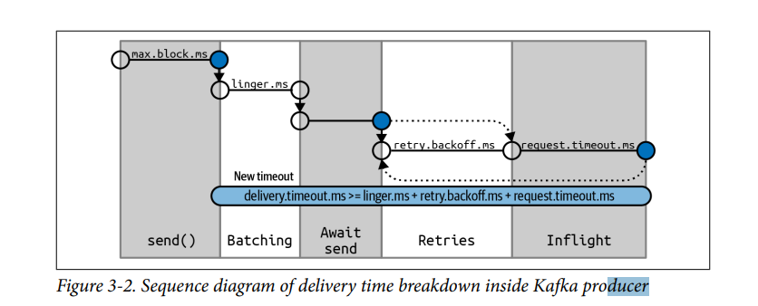

**max.block.ms**- This parameter controls how long the producer may block when calling send() and when explicitly requesting metadata via partitionsFor(). Those methods may block when the producer’s send buffer is full or when metadata is not available. When max.block.ms is reached, a timeout exception is thrown.

## Headers:-

Records can, in addition to key and value, also include headers. Record headers give you the ability to add some metadata about the Kafka record, without adding any extra information to the key/value pair of the record itself. Headers are often used for lineage to indicate the source of the data in the record, and for routing or tracing messages based on header information without having to parse the message itself.

Headers are implemented as an ordered collection of key/value pairs. The keys are always a String, and the values can be any serialized object—just like the message value. Here is a small example that shows how to add headers to a ProduceRecord:

ProducerRecord record = new ProducerRecord<>("CustomerCountry", "Precision Products", "France");

record.headers().add("privacy-level","YOLO".getBytes(StandardCharsets.UTF\_8));

## Idempotent Producer

A service is called idempotent if performing the same operation multiple times has the same result as performing it a single time. In databases it is usually demonstrated as the difference between UPDATE t SET x=x+1 where y=5 and UPDATE t SET x=18 where y=5. The first example is not idempotent; if we call it three times, we’ll end up with a very different result than if we were to call it once. The second example is idempotent—no matter how many times we run this statement, x will be equal to 18. How is this related to a Kafka producer? If we configure a producer to have at-leastonce semantics rather than idempotent semantics, it means that in cases of uncer‐ tainty, the producer will retry sending the message so it will arrive at least once. These retries could lead to duplicates. The classic case is when a partition leader received a record from the producer, repli‐ cated it successfully to the followers, and then the broker on which the leader resides crashed before it could send a response to the producer. The producer, after a certain time without a response, will resend the message. The message will arrive at the new leader, who already has a copy of the message from the previous attempt—resulting in a duplicate. In some applications duplicates don’t matter much, but in others they can lead to inventory miscounts, bad financial statements, or sending someone two umbrellas instead of the one they ordered

## How Does the Idempotent Producer Work?

When we enable the idempotent producer, each message will include a unique identi‐ fied producer ID (PID) and a sequence number. These, together with the target topic and partition, uniquely identify each message. Brokers use these unique identifiers to track the last five messages produced to every partition on the broker.

When a broker receives a message that it already accepted before, it will reject the duplicate with an appropriate error. This error is logged by the producer and is reflec‐ ted in its metrics but does not cause any exception and should not cause any alarm. On the producer client, it will be added to the record-error-rate metric.

## Transactions:-

As we mentioned in the introduction to this chapter, transactions were added to Kafka to guarantee the correctness of applications developed using Kafka Streams. In order for a stream processing application to generate correct results, each input record must be processed exactly one time, and its processing result will be reflected exactly one time, even in case of failure. Transactions in Apache Kafka allow stream processing applications to generate accurate results. This, in turn, enables developers to use stream processing applications in use cases where accuracy is a key requirement.

## How to Optimize Throughput of Producers and Consumers:-

o optimize for throughput, producers and consumers must move as much data as possible within a given amount of time. For high throughput, try maximizing the rate at which the data moves. The data rate should be the fastest possible rate.

**Producer configurations** to achieve a high throughput application are:

- **compression.type:** Producers usually send data that is text-based, for example with JSON data. In this case, it is important to apply compression to optimize for throughput. Compression is more effective the bigger the batch of messages being sent to Kafka. Possible values are: lz4 (recommended for performance),snappy, zstd, gzip.

- **batch.size:** With batching strategy of Kafka producers, you can batch messages going to the same partition, which means they collect multiple messages to send together in a single request. The most important step you can take to **optimize throughput** is to tune the producer batching to increase the batch size and the time spent waiting for the batch to populate with messages. Larger batch sizes result in fewer requests, which reduces load on producers and the broker CPU overhead to process each request.

- **linger.ms:** It's the number of milliseconds a producer is willing to wait before sending a batch out (defaults to 0). By introducing some lag, we increase the changes of messages being sent together in a batch. If the batch is full (batch.size) before the end of linger.ms period, it will be sent to Kafka right away.

## WORKERS:-

Mirroring Active-Active,Active-paaive?

## Kafka MirrorMaker Active-Active Architecture-

This architecture is used when two or more data centers share some or all of the data and each data center is able to both produce and consume events. Producers produce to the same topic in both the clusters, and mirroring occurs between two topics in the clusters.

In active –active architecture the two data centres share some or all of the data center and each data center is able to produce and consume events. producers produce to same topic in both clusters.

In active-passive architecture producer publish data to active cluster only. The passive cluster receive no writes, it just receive the mirrored data from active cluster by Mirror Maker.

## KAFKA CONNECT CONCEPTS:

* [Connectors](https://docs.confluent.io/platform/current/connect/index.html#connect-connectors): The high level abstraction that coordinates data streaming by managing tasks
* [Tasks](https://docs.confluent.io/platform/current/connect/index.html#connect-tasks): The implementation of how data is copied to or from Kafka
* [Workers](https://docs.confluent.io/platform/current/connect/index.html#connect-workers): The running processes that execute connectors and tasks
* [Converters](https://docs.confluent.io/platform/current/connect/index.html#connect-converters): The code used to translate data between Connect and the system sending or receiving data
* [Transforms](https://docs.confluent.io/platform/current/connect/index.html#connect-transforms): Simple logic to alter each message produced by or sent to a connector
* [Dead Letter Queue](https://docs.confluent.io/platform/current/connect/index.html#dead-letter-queues): How Connect handles connector errors

Connectors in Kafka Connect define where data should be copied to and from. A **connector instance** is a logical job that is responsible for managing the copying of data between Kafka and another system. All of the classes that implement or are used by a connector are defined in a **connector plugin**.

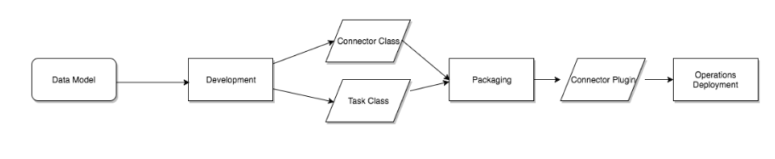

## Tasks:-

Tasks are the main actor in the data model for Connect. Each connector instance coordinates a set of tasks that copy data. By allowing the connector to break a single job into many tasks, Kafka Connect provides built-in support for parallelism and scalable data copying with minimal configuration.

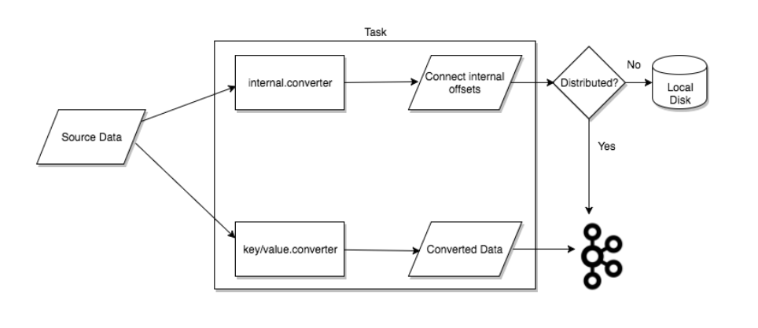

## Workers:-

Connectors and tasks are logical units of work and must be scheduled to execute in a process. Kafka Connect calls these processes **workers** and has two types of workers: [standalone](https://docs.confluent.io/platform/current/connect/index.html#standalone-workers) and distributed [distrubuted](https://docs.confluent.io/platform/current/connect/index.html" \l "distributed-workers).

StandAlone Workers:-

Standalone mode is the simplest mode, where a single process is responsible for executing all connectors and tasks. Since it is a single process, it requires minimal configuration.

## Distributed workers:-

Distributed mode provides scalability and automatic fault tolerance for Kafka Connect. In distributed mode, you start many worker processes using the same group.id and they coordinate to schedule execution of connectors and tasks across all available workers.

### **Transforms**

Connectors can be configured with transformations to make simple and lightweight modifications to individual messages. This can be convenient for minor data adjustments and event routing, and many transformations can be chained together in the connector configuration.However, more complex transformations and operations that apply to many messages are best implemented with [ksqlDB Overview](https://docs.confluent.io/platform/current/ksqldb/overview.html" \l "ksql-home) and [Kafka Streams for Confluent Platform](https://docs.confluent.io/platform/current/streams/overview.html#kafka-streams).

When transforms are used with a source connector, Kafka Connect passes each source record produced by the connector through the first transformation, which makes its modifications and outputs a new source record.

### **Dead Letter Queue**

Only applicable for sink connectors. An invalid record can occur due to multiple reasons.

Example-An invalid record may occur due to multiple of reasons. One example is when a record arrives at a sink connector serialized in JSON format, but the sink connector configuration is expecting Avro format. When an invalid record can’t be processed by the sink connector, the error is handled based on the connector errors.tolerance configuration property.

There are two valid values for errors.tolerance:

* none (default)
* all

When errors.tolerance is set to none, an error or invalid record causes the connector task to immediately fail and the connector goes into a failed state. To resolve this issue, you must review the Kafka Connect Worker log and do the following:

1. Examine what caused the failure.
2. Fix the issue.
3. Restart the connector.

When errors.tolerance is set to all, all errors or invalid records are ignored and processing continues. No errors are written to the Connect Worker log.

#### **Create a Dead Letter Queue topic**

errors.tolerance **=** all

errors.deadletterqueue.topic.name **=** <dead-letter-topic-name>

Even if the DQL topic contains the records that failed, it does not show why. You can add the following configuration property

errors.deadletterqueue.context.headers.enable**=**true

## unclean.leader.election.enable : true

Allows you to specify preference of **availability** and **durability.**

If **availability** is more important than avoiding data loss, ensure that this property is set to true. If **preventing data loss** is more important than availability, set this property to false.

If unclean.leader.election.enable is set to true (enabled), an out-of-sync replica will be elected as leader when there is no live in-sync replica (ISR). This preserves the availability of the partition, but there is a chance of data loss.

If unclean.leader.election.enable is set to false and there are no live in-sync replicas, Kafka returns an error and the partition will be unavailable.

## Kafka Streams: Exactly once ->

Kafka Streams supports **at-least-once** and **exactly-once** processing guarantees:

**- At-least-once semantics:**Records are never lost but may be redelivered. If your stream processing application fails, no data records are lost and fail to be processed, but some data records may be re-read and therefore re-processed. At-least-once semantics is enabled by default (processing.guarantee="at\_least\_once") in your Streams configuration.

- **Exactly-once semantics:**Records are processed once. Even if a producer sends a duplicate record, it is written to the broker exactly once. Exactly-once stream processing is the ability to execute a read-process-write operation exactly one time. All of the processing happens exactly once, including the processing and the materialized state created by the processing job that is written back to Kafka. To enable exactly-once semantics, set processing.guarantee="exactly\_once" in your Streams configuration.

**Note:** Exactly-once processing is guaranteed for **Kafka -> Kafka** workflows only.

## Group Coordinator:-

The group coordinator is nothing but one of the **brokers** which receives heartbeats from all consumers of a consumer group. **Every consumer group has exactly one group coordinator**. If a consumer stops sending heartbeats, the coordinator will trigger a rebalance.

When a consumer wants to join a consumer group, it sends a JoinGroup request to the group coordinator. The first consumer to join the group becomes the group leader.

What authentication methods are supported for authenticating to ZooKeeper, and what considerations should be taken into account when using mutual TLS (mTLS) authentication alone?

In a Kafka deployment using mTLS for authentication to ZooKeeper, it is essential to ensure that each broker and CLI tool has the same Distinguished Name (DN) when mTLS is used alone. This consideration is crucial for proper ACL'ing and secure communication between Kafka and ZooKeeper.

**From Kafka version 2.5** onward, Kafka supports authenticating to ZooKeeper with **SASL and mTLS individually or both together.** When using mTLS alone, every broker and CLI tool should identify itself with the same Distinguished Name (DN) for proper ACL'ing. This ensures that the DN is ACL'ed properly.

Using Kafka, how does a consumer commit an offset?

As a consumer in the group reads messages from the partitions assigned by the coordinator, it must commit the offsets corresponding to the messages it has read. If the consumer crashes or is shut down, its partitions will be re-assigned to another member, which will begin consumption from the last committed offset of each partition.

By default, the consumer is configured to auto-commit offsets. Using auto-commit gives you "at least once" delivery.

To commit offsets the consumer **produces a message** to Kafka, to a special \_\_consumer\_offsets topic, with the committed offset for each partition.

Which of the following choices is best practice when it comes to Kafka security concepts?

By default, there is no encryption or authentication, nor are ACLs configured. Any client can communicate to Kafka brokers using the PLAINTEXT port. It is critical that access using this port is restricted to trusted clients only. Network segmentation and / or authorization ACLs can be used to restrict access to trusted IPs in such cases. If neither is used, then the cluster is wide open and can be accessed by anyone.

While non-secured clusters are supported, as are a mix of authenticated, unauthenticated, encrypted and non-encrypted clients, **it is recommended to secure the components** in your deployment.

**For authorization** it's a best practice to create one principal per application and give each principal only the ACLs it requires and no more.

What is the purpose of the **bootstrap.servers** configuration in ksqlDB?

The **bootstrap.servers** configuration in ksqlDB specifies the initial connection point to the Kafka cluster. It is defined as a comma-separated list of host and port pairs (**host:port**). This configuration is crucial for ksqlDB to establish its connection to the Kafka cluster and is used during the initialization phase to discover the Kafka brokers and join the Kafka cluster.

Consider a scenario where you are configuring a ksqlDB server to connect to a Kafka cluster with brokers located at **kafka1:9092**, **kafka2:9092**, and **kafka3:9092**.

You would set the **bootstrap.servers** configuration in the ksqlDB server properties file as follows:

1. bootstrap.servers=kafka1:9092,kafka2:9092,kafka3:9092

This ensures that ksqlDB knows where to find the Kafka cluster during its operation

## KSQLDB SQL STATEMENTS-

There may be another process running on the port that the ksqlDB server listens on. Use the following command to check the process that’s running on the port assigned to the ksqlDB server. The following example checks the default port, which is 8088.

### **No results from SELECT \* FROM table or stream?**

This is typically caused by the query being configured to process only newly arriving data instead, and no new input records are being received. To fix, do one of the following:

* Run SET 'auto.offset.reset' = 'earliest';.

Kafka's ProducerRecord is a key / value pair to be sent to Kafka. This consists of a **topic** name to which the record is being sent, an optional **partition** number, and an optional **key** and **value**.

If a valid partition number is specified that partition will be used when sending the record. If no partition is specified but a key is present a partition will be chosen using a hash of the key. If neither key nor partition is present a partition will be assigned in a round-robin fashion.

The example uses the following constructor:

1. ProducerRecord(String topic, K key, V value)
2. -> Creates a key / value record to be sent to Kafka

The following constructor could be used if you want to send the message to a specific partition:

1. ProducerRecord(String topic, Integer partition, K key, V value)
2. -> Creates a record to be sent to a specified topic and partition.